Science Challenge 1:

Draw an invention to keep people two metres apart

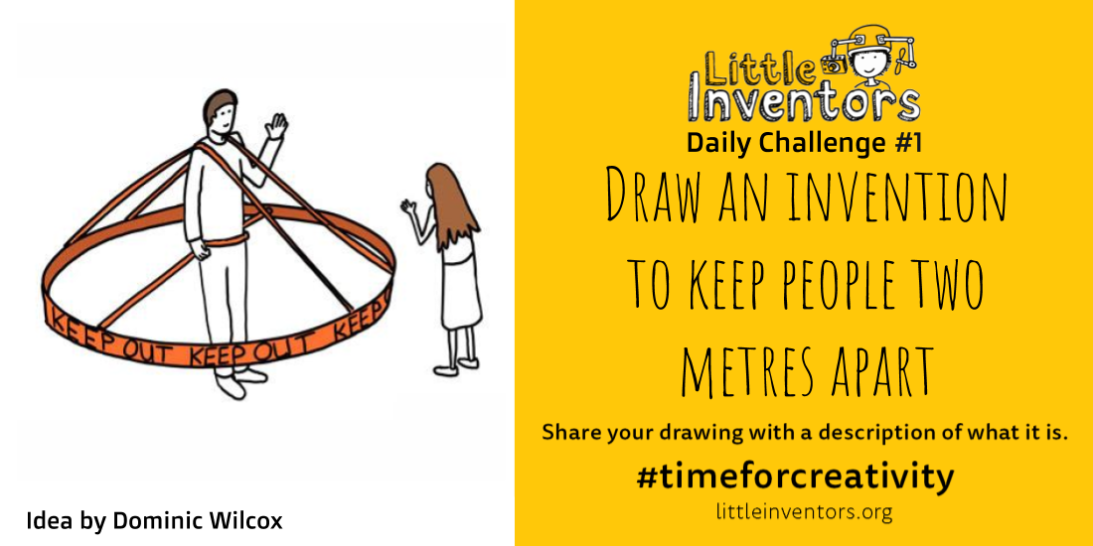
Idea by Dominic Wilcox

What ideas can you think of that will keep people staying 2 metres apart?
Take the challenge and upload your drawings onto Dojo message board.
We can't wait to see your ideas!

