Ongoing Weekly Science Tasks – Year 2
Animals including humans
- Try and complete two activities per week. Pick the activity your child is interested in doing. You can record anything in your exercise book. Pictures and artwork can be stuck in their books All the activities should be attached below. If you have any difficulties please let me know by using the Class dojo app.
Science Aims:
- To find out about and describe the basic needs of animals, including humans, for survival (water, food and air).
- To describe the importance for humans of exercise, eating the right amounts of different types of food, and hygiene.
Activities:
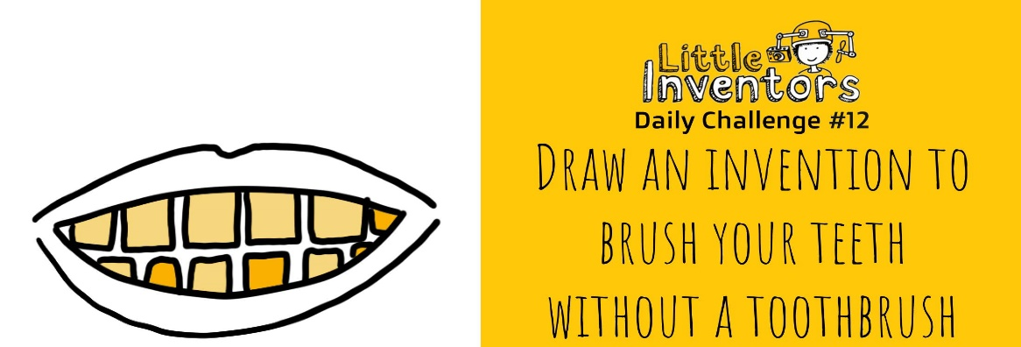

- How can you keep your teeth clean, without using a toothbrush?

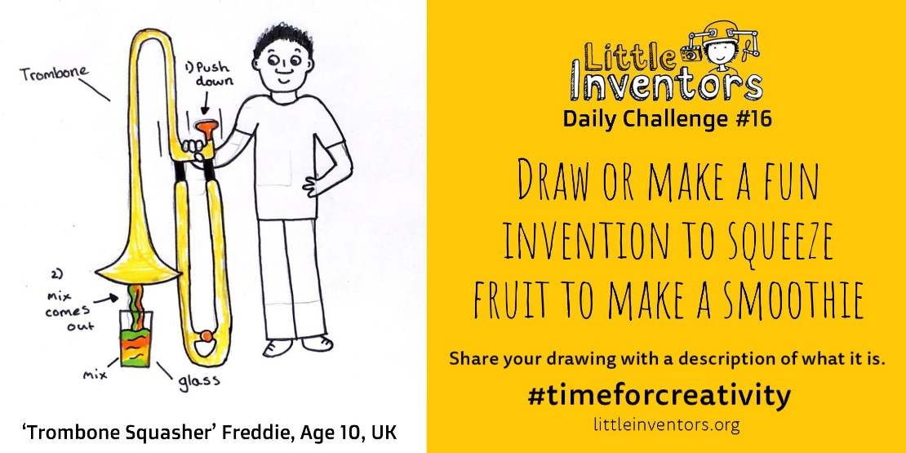

- How can you make a delicious smoothie?
- Have fun!

Please send photos of any completed work to share on the Class dojo app.

