What to do today
IMPORTANT Parent or Carer – Read this page with your child and check that you are happy with what they have to do and any weblinks or use of internet.

1. Read a poem
- Read Sea Fever. Read it twice: once in your head and once out loud.
- Read the Poetry Questions. Think about your answers and then write them as sentences.

2. Remind yourself about possessive apostrophes
- Use the PowerPoint on possessive apostrophes or, if this is not possible, remind yourself using the Revision Card.
- Complete Sea Fever Sentences.
- Read the copy of Sea Fever without apostrophes for possession. Work out where the missing apostrophes go.

3. Practise reading the poem aloud
- Listen to these two readings of the poem:
https://www.youtube.com/watch?v=39hLh_QFqQo
https://www.youtube.com/watch?v=TCYsLqV2CyU&t=6s
The second is read by the poet himself. (It’s quite particular!) Which do you prefer?
- Read Top Tips for reading a poem aloud.
- Practise reading Sea Fever out loud until you can read it really confidently.

Well done. Read the poem to a grown-up. You can check the answers to Sea Fever Sentences at the end of this pack.

Try the Fun-Time Extra
- Where do you wish to go again? Write and draw your answer.
Sea Fever

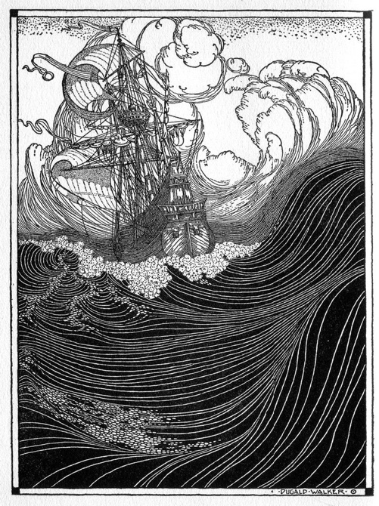

I must go down to the seas again, to the lonely sea and the sky,
And all I ask is a tall ship and a star to steer her by;
And the wheel’s kick and the wind’s song and the white sail’s shaking,
And a grey mist on the sea’s face, and a grey dawn breaking.

I must go down to the seas again, for the call of the running tide
Is a wild call and a clear call that may not be denied;
And all I ask is a windy day with the white clouds flying,
And the flung spray and the blown spume, and the sea-gulls crying.

I must go down to the seas again, to the vagrant gypsy life,
To the gull’s way and the whale’s way where the wind’s like a
whetted knife;
And all I ask is a merry yarn from a laughing fellow-rover,
And quiet sleep and a sweet dream when the long trick’s over.

John Masefield, p223

Poetry Questions

What do you like about the poem? Is there anything you dislike? What does it remind you of? How does it make you feel?
What patterns can you find? Is there any rhyme, alliteration or assonance? Is anything repeated?
What interesting words or phrases can you find? What do they mean? Are there any metaphors or similes? Are there any vivid descriptions?

Revision Card – Possessive Apostrophes

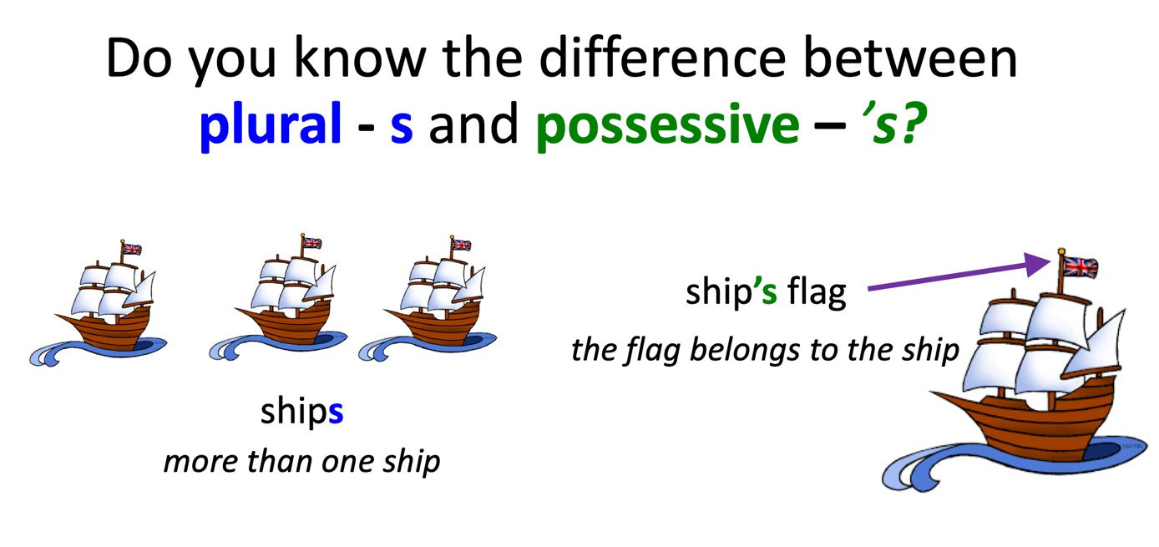
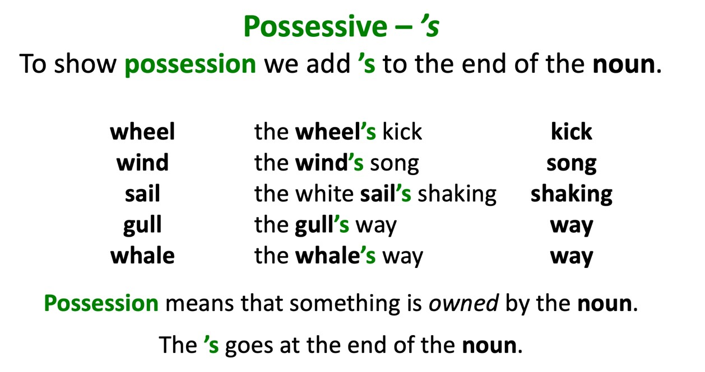
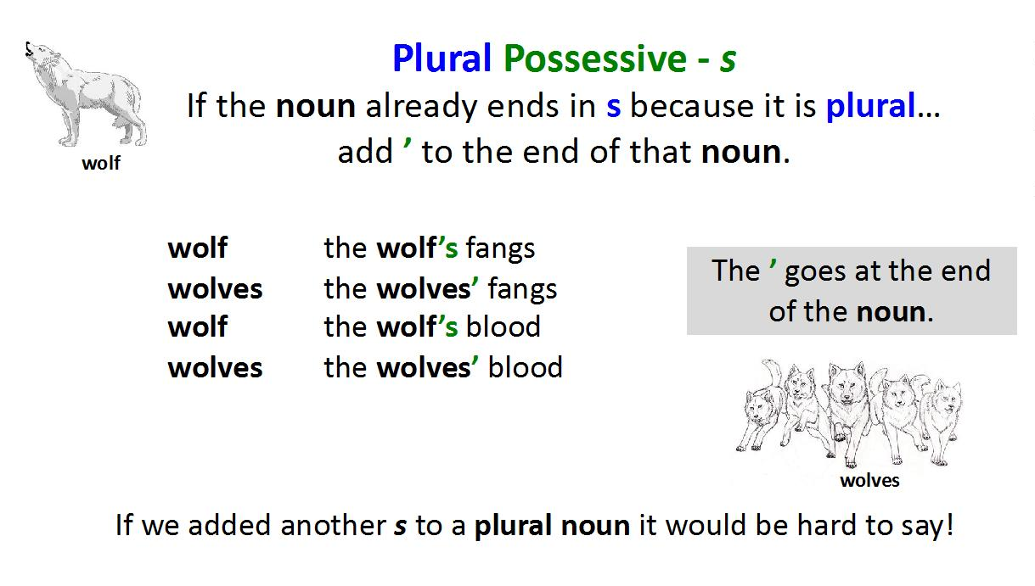

Sea Fever Sentences

Add possessive apostrophes.
Remember that not all words ending in -s need them!



- The poet longs to live a sailors life.
- He loves to hear the sounds that the sail and the winds make.
- Sailors can use a stars light to steer their ships.
- Sailors see the sea in all its moods.
- The running tides call is described as being a wild call and a clear call.
- The seagulls cry is another sound mentioned in the poem.
- Gulls appear twice in the poems lines.
- John Masefields poem was written in 1902.
- The poems three verses each start with the same opening lines.
- ‘The long trick’ is this poets way of describing life.

Sea Fever – without apostrophes for possession

I must go down to the seas again, to the lonely sea and the sky,
And all I ask is a tall ship and a star to steer her by;
And the wheels kick and the winds song and the white sails shaking,
And a grey mist on the seas face, and a grey dawn breaking.

I must go down to the seas again, for the call of the running tide
Is a wild call and a clear call that may not be denied;
And all I ask is a windy day with the white clouds flying,
And the flung spray and the blown spume, and the sea-gulls crying.

I must go down to the seas again, to the vagrant gypsy life,
To the gulls way and the whales way where the wind’s like a whetted knife;
And all I ask is a merry yarn from a laughing fellow-rover,
And quiet sleep and a sweet dream when the long trick’s over.

Top tips for reading a poem aloud

- Work on the tricky words. Find out what they mean and how they are said. Practise saying them.
- Look for the full stops. Make sentences flow to the full stop, even when there’s a new line.
- Slow down. Speak slowly when you’re reading a poem, so that others can hear the words.
- Project your voice. Imagine someone on the other side of the room and speak to them.
- Practise. Read and read and read your poem, so that you get better each time.



Sea Fever Sentences - Answers

- The poet longs to live a sailor’s life.
- He loves to hear the sounds that the sail and the winds make.
- Sailors can use a star’s light to steer their ships.
- Sailors see the sea in all its moods.
- The running tide’s call is described as being a wild call and a clear call.
- The seagull’s cry is another sound mentioned in the poem.
- Gulls appear twice in the poem’s lines.
- John Masefield’s poem was written in 1902.
- The poem’s three verses each start with the same opening lines.
- ‘The long trick’ is this poet’s way of describing life.

Sea Fever – ANSWERS

I must go down to the seas again, to the lonely sea and the sky,
And all I ask is a tall ship and a star to steer her by;
And the wheels’ kick and the wind’s song and the white sails shaking,
And a grey mist on the sea’s face, and a grey dawn breaking.

I must go down to the seas again, for the call of the running tide
Is a wild call and a clear call that may not be denied;
And all I ask is a windy day with the white clouds flying,
And the flung spray and the blown spume, and the sea-gulls crying.

I must go down to the seas again, to the vagrant gypsy life,
To the gulls’ way and the whales’ way where the wind’s like a whetted knife;
And all I ask is a merry yarn from a laughing fellow-rover,
And quiet sleep and a sweet dream when the long trick’s over.

