What to do today
IMPORTANT Parent or Carer – Read this page with your child and check that you are happy with what they have to do and any weblinks or use of internet.

1. Fill in missing words
- King of Rome – Cloze.
- What words could go in the black spaces? Write at least one word for each space.
- Listen to the song to check your answers:
https://www.youtube.com/watch?v=asbcMaegOT4

2. Write some sentences
- Use the Revision Card to remind yourself about direct speech and reporting clauses.
- Choose five of the Said Synonyms. Use them to write sentences with direct speech and reporting clauses.

3. Write a paragraph
- Look at Illustrations 1-4 from the King of Rome.
- Imagine what the characters could be saying.
- Choose one of the illustrations and write a paragraph to tell this part of the story. Include direct speech in your paragraph.

Well done. Read your paragraph to a grown-up and show them the illustration that you were writing about.

Try these Fun-Time Extras
- Look in a reading book and collect other synonyms for said.
- Try to learn to sing the King of Rome. This chord chart might help you:
https://tabs.ultimate-guitar.com/tab/half-man-half-biscuit/the-king-of-rome-chords-1487346

King of Rome by Dave Sudbury - Cloze

In the West End of Derby lives a working man
He says "I can't fly but me pigeons can
And when I set them free
It's just like part of me
Gets lifted up on shining wings"

Charlie Hudson's pigeon loft was down the yard
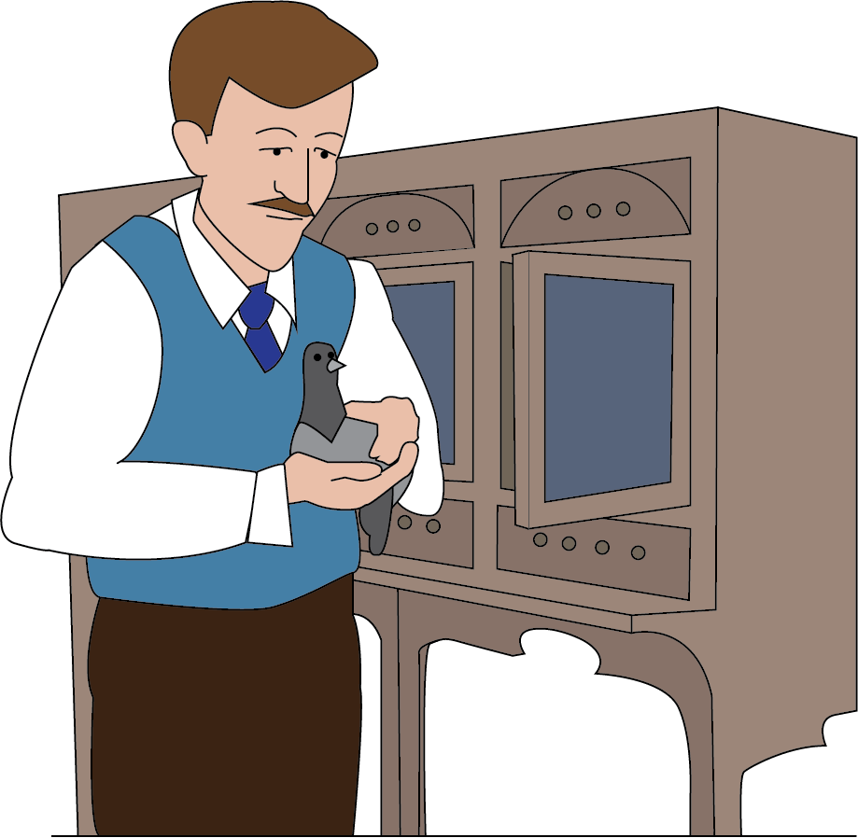
Of a rented house in Brook Street where life was hard
But Charlie had a dream
And in 1913
Charlie bred a pigeon to make his dream come true

There was gonna be a champions' race from Italy
We got out the maps, all that land and sea
“Charlie, you'll lose that bird"
But Charlie never heard
He put it in a basket and sent it off to Rome

On the day o' the big race a storm blew in
A thousand birds were swept away and never seen again
"Charlie we told you so
Surely by now you know
When you're living in the West End there ain't many dreams come true"

"Yeah, I know, but I had to try
A man can crawl around or he can learn to fly
And if you live 'round here
The ground seems awful near
Sometimes I need a lift from victory"

I was off with me mates for a pint or two
When I saw a wing flash up in the blue
"Charlie, it's the King of Rome

Come back to his West End home
Come outside quick, he's perched up on your roof"

"Come on down, your majesty
I knew you'd make it back to me
Come on down, you lovely one
You made me dream come true"

In the West End of Derby lives a working man
He says "I can't fly but me pigeons can
And when I set them free
It's just like part of me
Gets lifted up on shining wings"

Revision Card

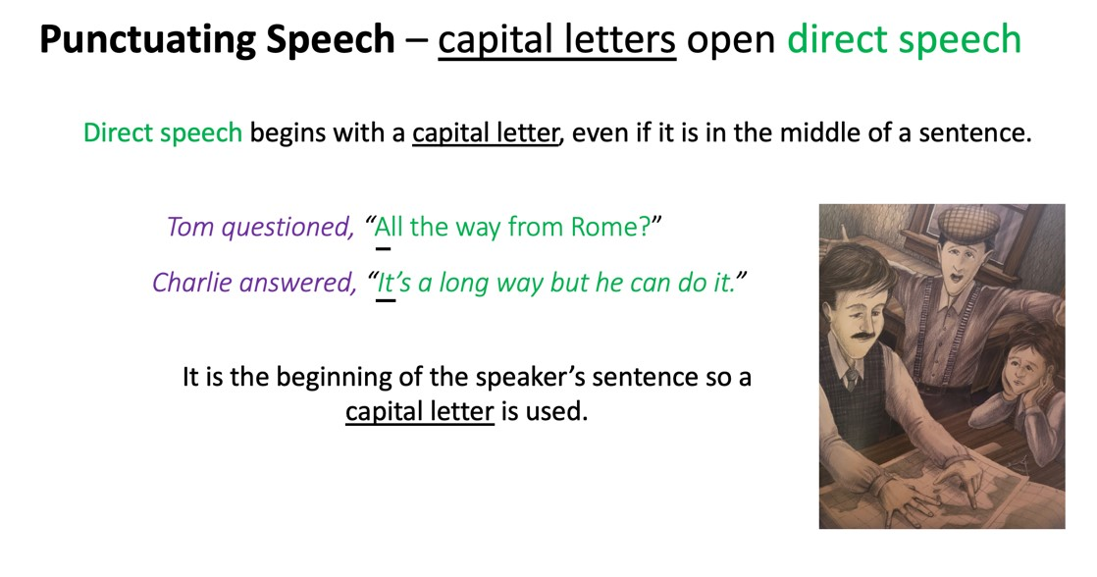 | 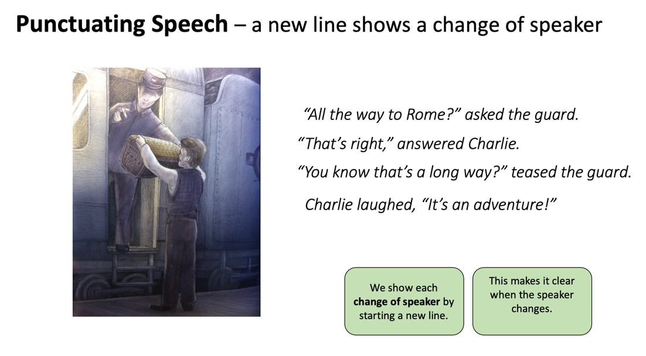
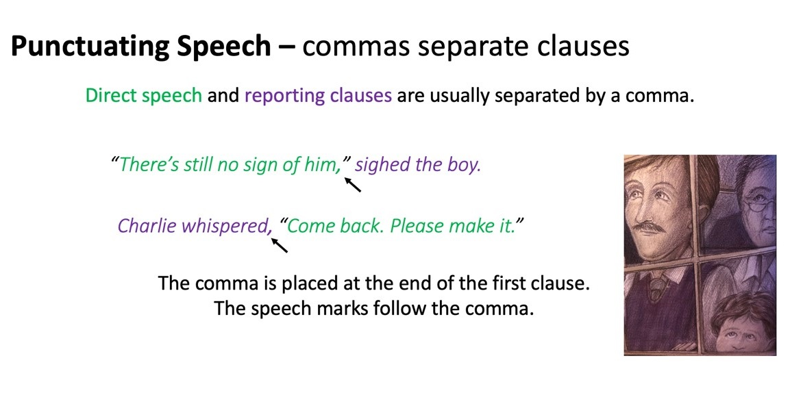 | 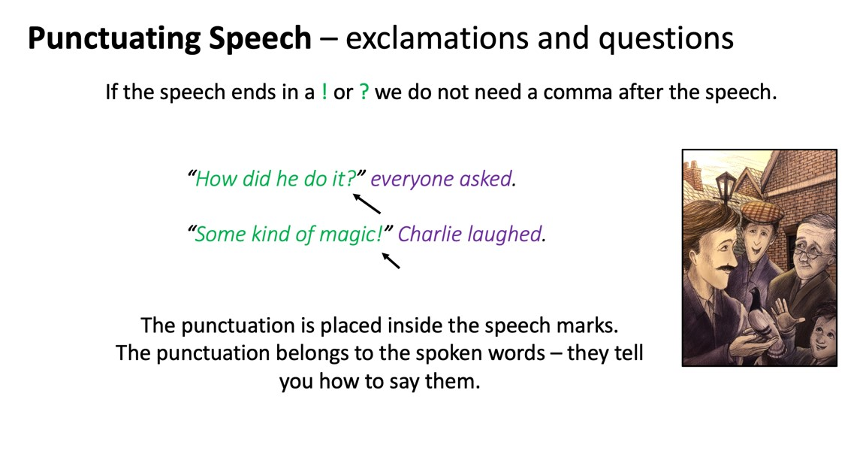

Said Synonyms

Anger
Shouted, bellowed, yelled, snapped, cautioned, rebuked.

Affection
Consoled, comforted, reassured, admired, soothed.

Excitement:
Shouted, yelled, babbled, gushed, exclaimed.

Fear:
Whispered, stuttered, stammered, gasped, urged, hissed, babbled, blurted.

Determination:
Declared, insisted, maintained, commanded.

Happiness:
Sighed, murmured, gushed, laughed.

Sadness:
Cried, mumbled, sobbed, sighed, lamented.

Amusement
Teased, joked, laughed, chuckled, chortled, sniggered, guffawed, giggled, roared.

Illustration 1
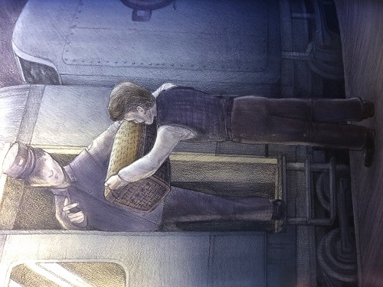

By Hans Saefkow

Illustration 2

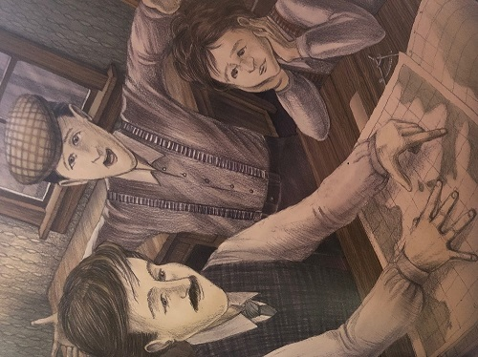
By Hans Saefkow

Illustration 3



By Hans Saefkow

Illustration 4

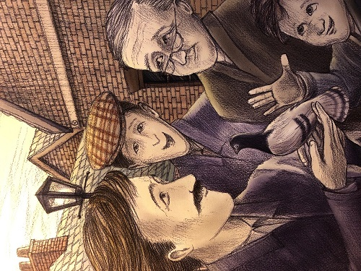

King of Rome - Paragraph

Pick one of the illustrations and write a paragraph to tell that part of the story. Include direct speech in your paragraph.



