What to do today
IMPORTANT Parent or Carer – Read this page with your child and check that you are happy with what they have to do and any weblinks or use of internet.

1. Watch an animation
- Watch Bembo’s Zoo. https://www.youtube.com/watch?v=pmEph902N8w
- How would you explain what happens to someone else? Which is your favourite animation? Which do you think looks most like the animal itself?

2. Investigate some designs
- Look at the design for ‘Octopus’ on Bembo’s Zoo Examples. Can you find every letter of the word?
- On Letter by Letter, describe the part of the octopus that each letter is representing.
- Challenge yourself to investigate the designs for Hippopotamus and Antelope as well.

3. Try making your own calligram
- These designs are types of calligram. Pick one from Animals or choose an animal (or dinosaur) of your own.
- Write out the letters in the name of the animal and then try arranging them into the shape of the animal. Work in pencil first and then draw your final design in pen.

Show your design to a grown-up. Ask them to watch Bembo’s Zoo with you so that they understand the idea of a calligram.

Try the Fun-Time Extra
- Can you make calligrams using the names of people in your family? Which name is easiest to do? Which is hardest? Which letters are most useful to have?

Bembo’s Zoo Examples

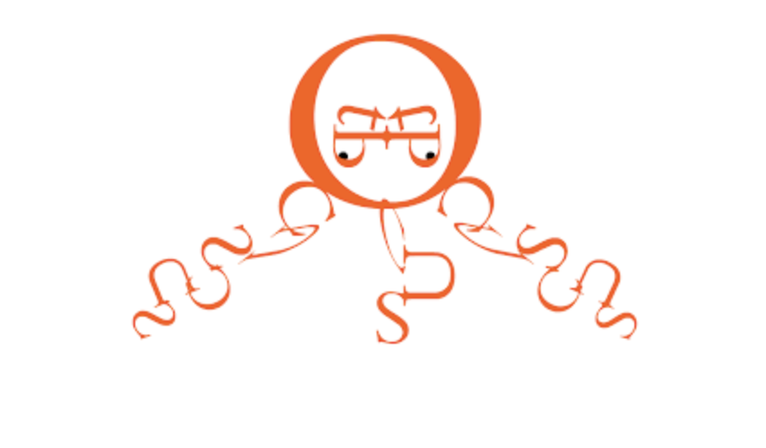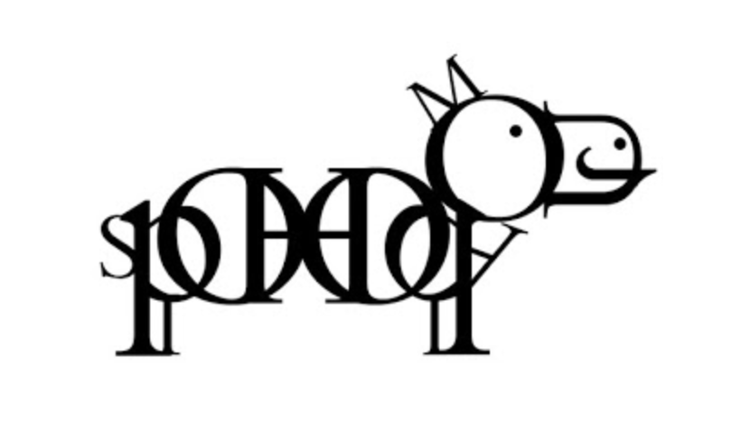
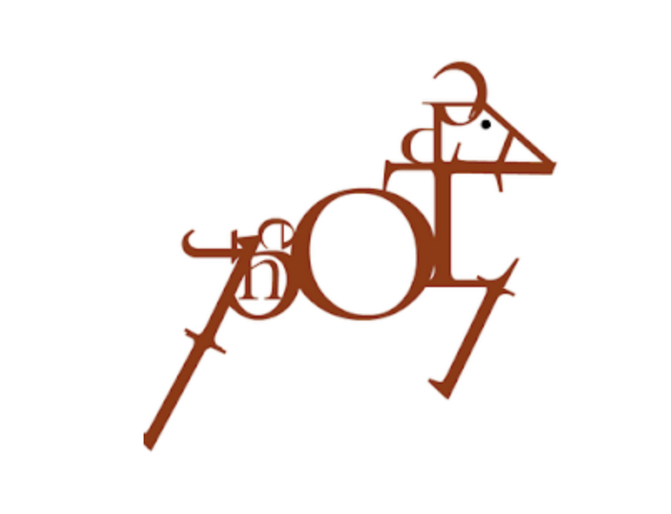

Bembo’s Zoo – Letter by Letter

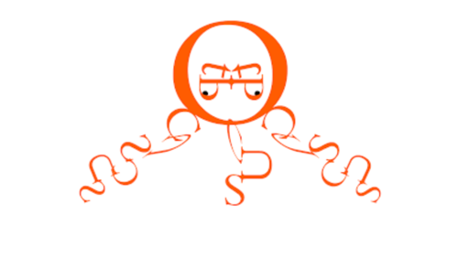

Letter | How is it used?
O
C
T
O
P
U
S

Bembo’s Zoo – Letter by Letter

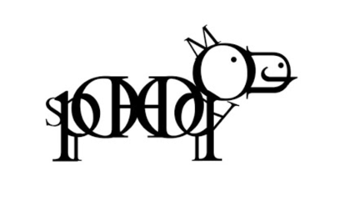

Letter | How is it used?
H
I
P
P
O
P
O
T
A
M
U
S

Bembo’s Zoo – Letter by Letter

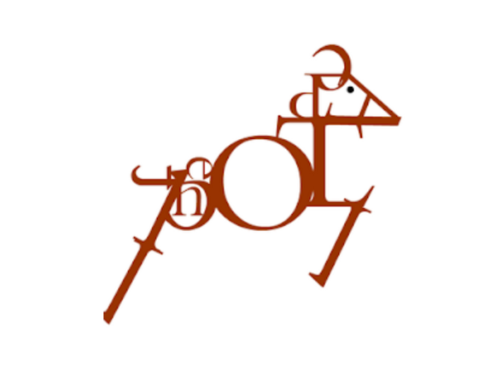

Letter | How is it used?
A
N
T
E
L
O
P
E

Animal Pictures

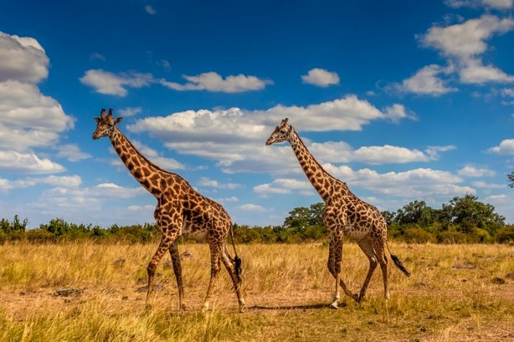 | 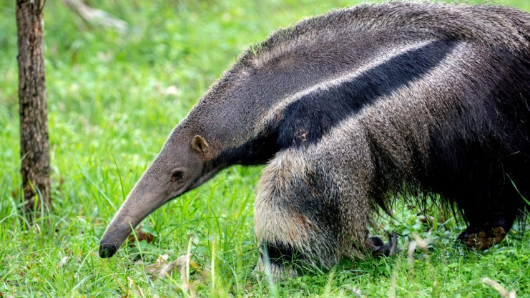
 | 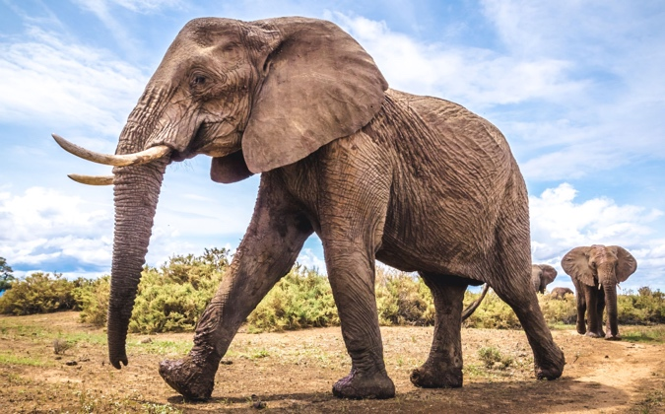
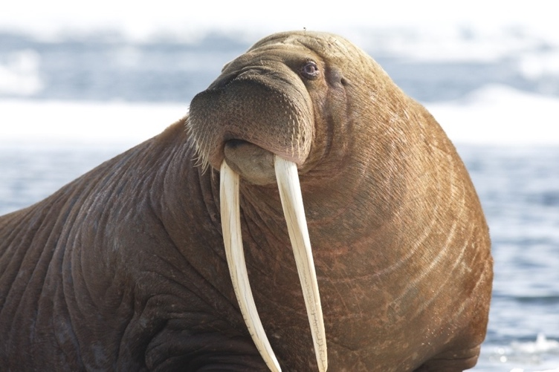 | 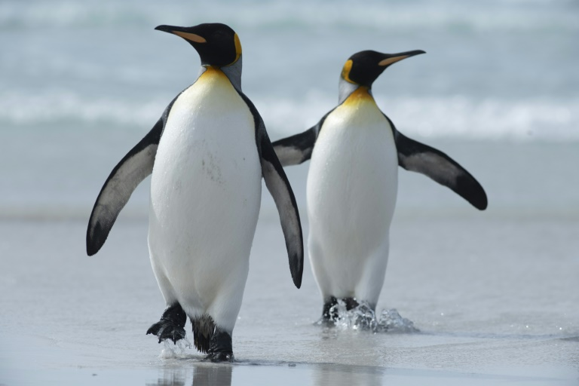
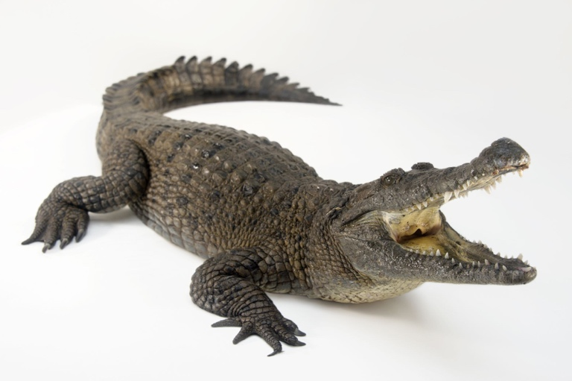 | 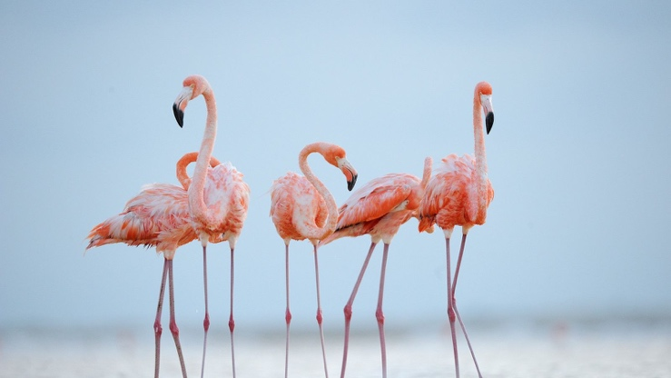

Design your own calligram

Pick an animal. Write out the letters from its name. Arrange them to make the shape of the animal.

