TARZAN
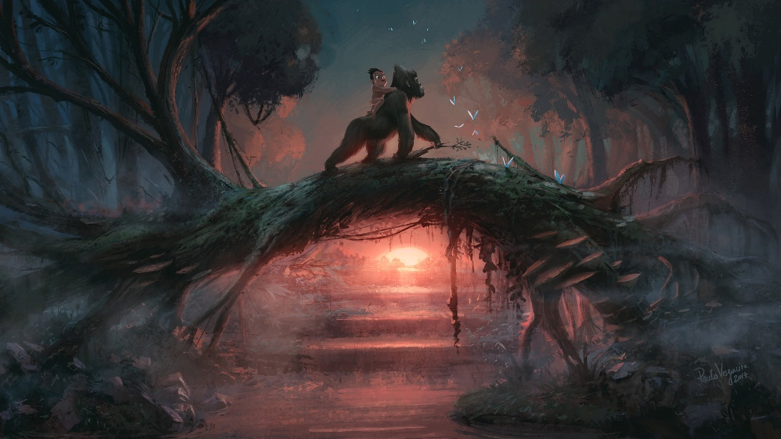

- Describe this setting. How could you describe the trees? The vines? The light and shadows?
- What time of day is it?
- Why is Tarzan riding on the back of an ape?
- Can Tarzan trust the ape? Can the ape trust Tarzan?
- Where are they going?
- Compare the stories of Tarzan and Mowgli (The Jungle Book). What’s similar and what’s different?
- Write your own story about a child raised by animals.

