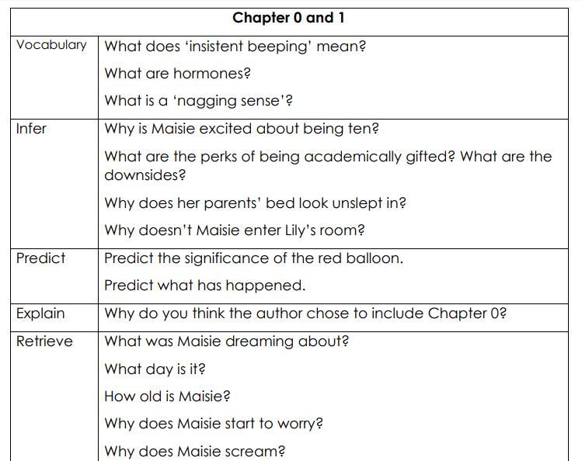
Read the extract of ‘The Infinite Lives of Maisie Day’ and answer the questions below in your books.

