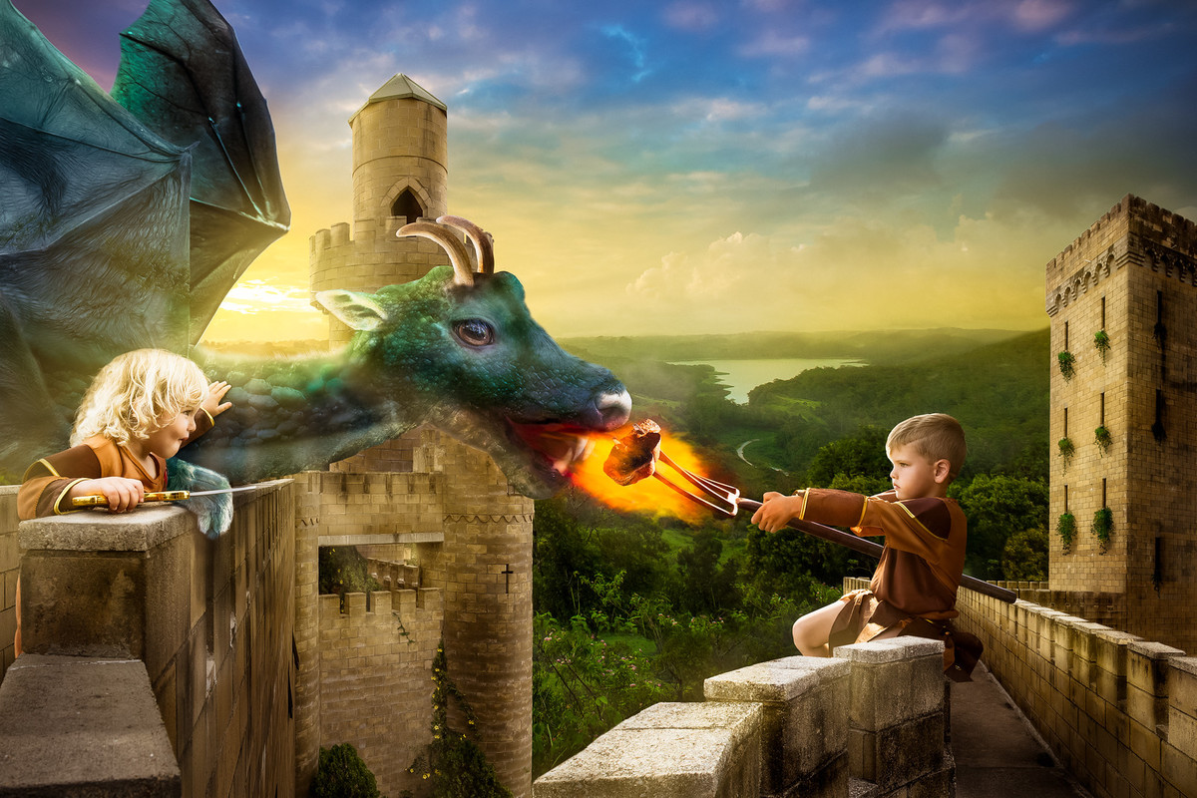Question time starter!
Why has the King given his children a dragon?
Do you think it’s a wise decision?
Where do the children live?
Can you think of a good name for their kingdom?
Why do you think the children will need ‘all the help they can get’ when they come to rule?
Can you think of names for the children?

Story starter (continue the story using this picture )
The King had known that the gift he presented to his children on their 5th birthday was dangerous. He was prepared to take the risk of letting them own a pet dragon, however. One day, the twins would rule the kingdom together, and they would need all the help they could get. No-one could deny that their dragon was a powerful ally.
The day to rule however, came quicker than either of them could ever imagine…

