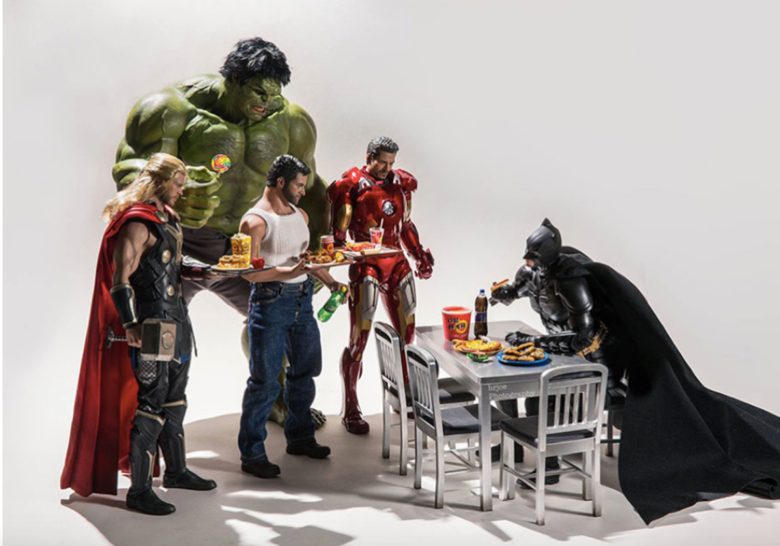
Question time starter!
Can you recognise each of the characters?
What do you think each of them do on a daily basis?
What do you think each of their favourite foods might be?
What do you think each of the characters are really like?

Story starter (continue the story using this picture )
Despite being a superhero, spending the majority of his time battling against crime and dangerous villains in Gotham City with an array of different skills and deadly weapons, Batman had a weakness for chicken nuggets.
The other superheroes were also making the most of their afternoon off from saving the world. However, they didn’t have long…

