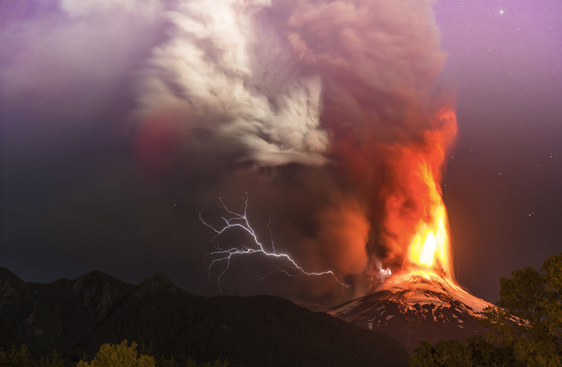Question time starter!
What do you think it means by ‘nature taking its revenge’?
What do you think is the most dangerous part of a volcano?
Do you know of any active volcanoes around the world?
Do you know what causes a volcano to erupt?
There is a famous volcano called Vesuvius, which erupted in Roman times to destroy the citizens of Pompeii. How do you think people felt thousands of years ago when they saw a volcanic eruption?
How do you think people explained where the lava came from? Remember, people used to think the Earth was flat!

Story starter (continue the story and include lots of description!)
It was the moment they had been dreading for decades: the volcano had finally erupted…

