TOPIC 13.7.20
Challenge 1 – Continuing with ANCIENT GREECE. Follow the link to find out more about Greek Gods… http://www.primaryhomeworkhelp.co.uk/greece/greekgods.htm

Follow the hyperlink to discover details about different Gods…


Choose 3 of the Gods to make fact-files on… sketch each one you choose and present the main details about them, using sub-headings.
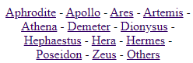
For example, you might choose to organise the information with…
Appearance Symbol Relationships An interesting tale

Challenge 2–Answer these questions about ‘The Quest of Medusa’s Head’ using the text below.
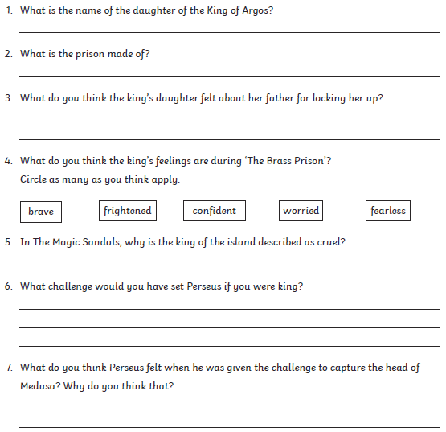

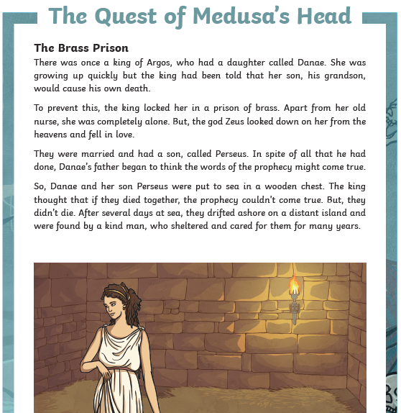
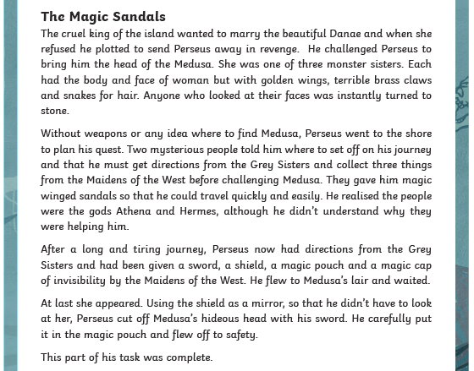

Challenge Questions


