TOPIC 6.7.20
Challenge 1 – Continuing with ANCIENT GREECE. Follow the link to find out more about GREEK MYTHS… http://www.primaryhomeworkhelp.co.uk/greece/myths.htm

Find out about any of the myths that are named on that page by searching for child-friendly versions of the stories.
Watch this retelling of the story of ‘Theseus and the Minotaur’ by following this link… https://www.youtube.com/watch?v=xQuAUBX5xBw

How is this animated version different to the written one lower down this page? Make a list of similarities and differences.
Why do you think these stories vary in content?
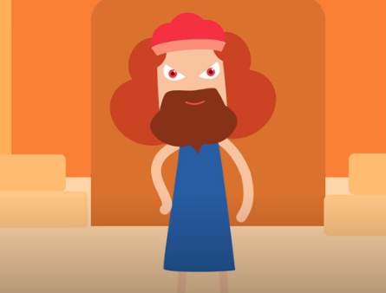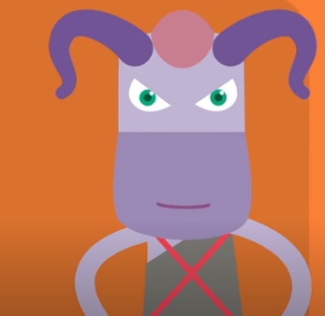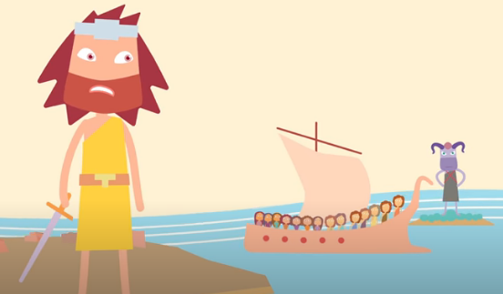

Challenge 2 – Answer these questions about ‘Theseus and the Minotaur’ using the text below.
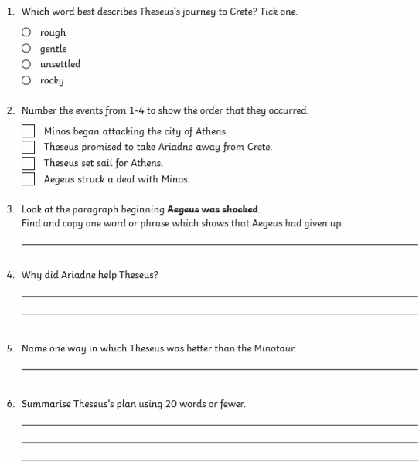

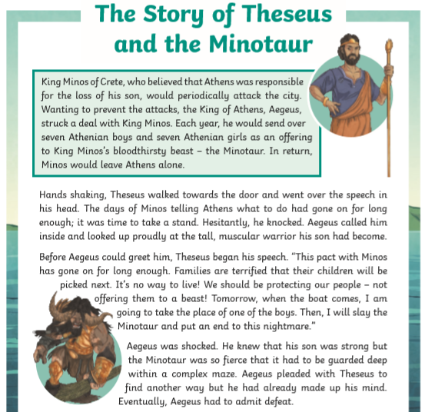
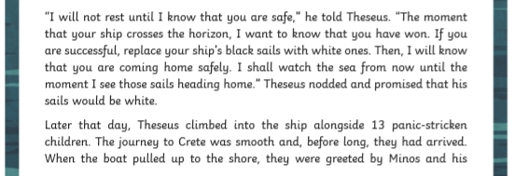
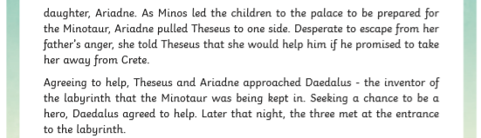
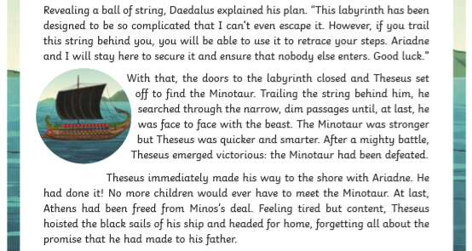
Challenge Questions


