TOPIC 29.6.20
Challenge 1 – Continuing with ANCIENT GREECE. This work follows on from last week about artefacts. Look at these images of jars…
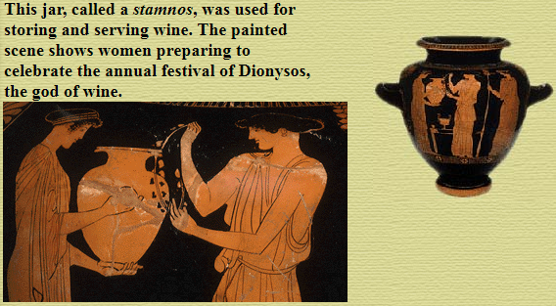
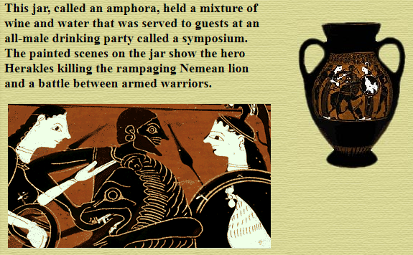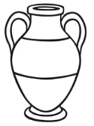

Design your own Greek jar. Use GOOGLE IMAGES to check out other images before you begin.
Enjoy being creative and try to use similar colours to make sure that your design is more realistic.

Challenge 2 – Answer these questions about ‘PANDORA’S BOX’ using the text below.
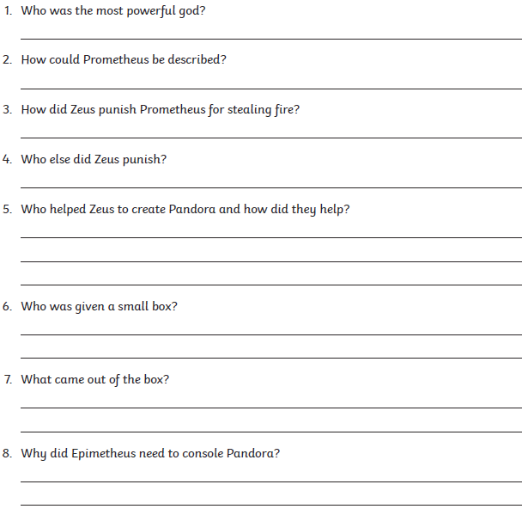

Pandora’s Box
A long time ago in Ancient Greece, there lived two brothers named Epimetheus and Prometheus. They were good gods with very kind hearts. Zeus, the most powerful of all gods, had hidden fire from mankind, never allowing them to make tools or cook their food. Prometheus, with his kind heart, thought this was unfair.
Prometheus was clever and knew that on the Isle of Lemnos lived Hephaestos, who was a blacksmith. Zeus allowed Hephaestos to use fire to make things for the gods. Prometheus travelled to Lemnos and stole the fire from Hephaestos and gave it to man. He also taught humans civilizing arts such as writing, medicine, mathematics and science.
Zeus was furious at Prometheus and, as punishment, chained him to the side of a cliff for many years. Zeus decided that the humans also needed to be punished for their lack of respect. Zeus was creative when it came to revenge and therefore came up with a very cunning plan.
With the help of Hephaestos, he sculpted a woman out of clay. The goddess Athena breathed life into the clay and the woman came to life. Aphrodite made her beautiful and Hermes taught her how to be both charming and deceitful. Zeus called her Pandora and sent her to Epimetheus, as he knew that he was lonely.
Epimetheus went to visit his brother and Prometheus warned him not to accept any gifts from the gods. However, Epimetheus was so charmed by Pandora that he thought she could never cause any harm. Zeus was pleased that his plan was working and, as a wedding gift, gave Pandora a small box.
When Pandora was given the box, she instantly became curious. The box was locked, but had a small key and a note attached to it that said ‘DO NOT OPEN!’ Pandora had promised that she would not open the box, but all she could think about was its contents. Why would someone send her a box and not allow her to open it? Pandora could no longer stand the torture of not knowing what was in the beautiful box.
When she knew that Epimetheus was out of sight, Pandora placed the box on the floor and took the small gold key. She closed her eyes and took a deep breath as she unlocked the box. She opened her eyes and pulled the box open, expecting to see fine silk dresses and jewellery. But there was not one gold bracelet or fine silk dress in sight! Instead, Zeus had packed terrible evils into the box and out poured sickness, death, poverty and sadness in the form of a horrible black mass.
Pandora slammed the lid shut, but it was too late; the evils had already escaped into the world. Epimetheus heard her weeping and ran into the room to console her. Pandora could still hear a tiny voice inside the box, pleading to be released. Epimetheus and Pandora thought that nothing could be worse than the horrors that had already been released, so together they opened the box. Out fluttered hope in the form of a beautiful gold dragonfly, healing some the sickness and sorrow.
Even though Pandora had released suffering and sadness upon the world, she had also released hope, and this made all the difference in the world.

