TOPIC 22.6.20
Challenge 1 – Continuing with ANCIENT GREECE. Use this website to find out about the evidence that has been collected by many archaeologists…http://www.primaryhomeworkhelp.co.uk/greece/howweknow.htm

Now, follow the next link to look at specific pieces of evidence that have been found.
https://archive.artic.edu/cleo/index.html

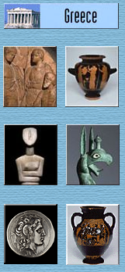

For each of the artefacts, sketch the object and make notes on the details you can find out.
Remember, be curious and take the time to find out as much as you can about other interesting discoveries.

Challenge 2 –


