TOPIC 15.6.20
Challenge 1 – Continuing with ANCIENT GREECE. Use this website to find out about Famous Greeks… http://www.primaryhomeworkhelp.co.uk/greece/famous.htm http://socrates.clarke.edu/aplg0260.htm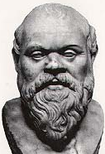

Focus on Socrates, but be curious about the other famous Greeks… https://www.youtube.com/watch?v=yH86jaBQ0F4 …make notes on his life and the important ideas he had.  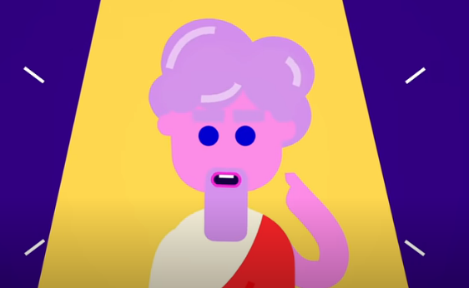 

Challenge 2 –


