TOPIC 8.6.20
Challenge 1 – Continuing with ANCIENT GREECE. Use this website to find out about Greece…
http://www.primaryhomeworkhelp.co.uk/greece/today.html

Make a sketch of the country and label it with the main features…make notes on the country and draw the flag too.
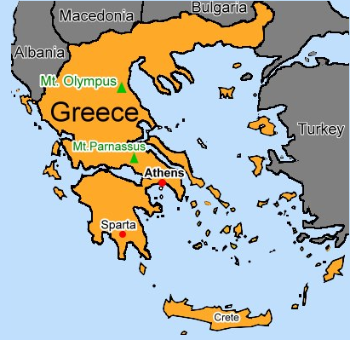

Challenge 2 –


