TOPIC 1.6.20
Challenge 1 – A change of focus… ANCIENT GREECE. Use this website to find out about the Ancient Olympics…
http://www.primaryhomeworkhelp.co.uk/greece/sports.htm
Follow this link to find and answer the following questions…
http://www.perseus.tufts.edu/Olympics/faq8.html
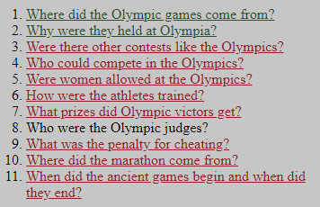

Challenge 2 –



