TOPIC 25.5.20
Challenge 1 –
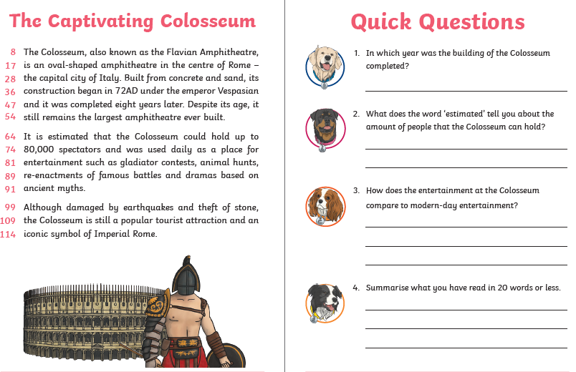

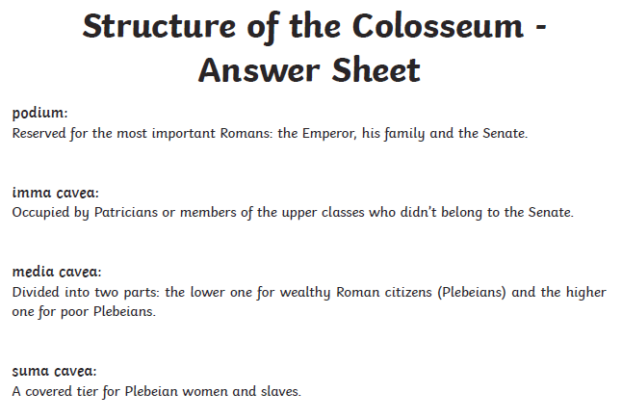
Challenge 2 – Sketch and label the Colosseum, using the image and labels provided. (The answers are on the next page…ssshhhhh!)


