TOPIC 18.5.20
Challenge 1 –
Create a fact-file on ROMAN GODS, using the websites: http://www.primaryhomeworkhelp.co.uk/romans/gods.htm
https://www.youtube.com/watch?v=iPAwnvyN6xw

https://www.bbc.co.uk/bitesize/clips/zqsygk7 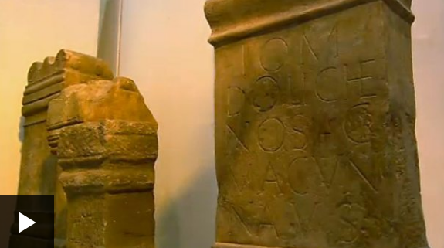
Use sub-headings to help to organise your new knowledge, include illustrations and find out the meaning of any vocabulary you aren’t sure about.
Be curious and see where it takes you!

Challenge 2 –


