TOPIC 4.5.20
Challenge 1 –
Create a fact-file on ROMAN BATHS, using the website: http://www.primaryhomeworkhelp.co.uk/romans/baths.html

Create a GLOSSARY of the new vocabulary you have now learned (what each word means). You should now know the difference between the TEPIDARIUM, the CALDARIUM and the FRIGIDARIUM!

Challenge 2 – Using the same website… http://www.primaryhomeworkhelp.co.uk/romans/baths.html
…look at the image of the Chester (Deva) Bath House.
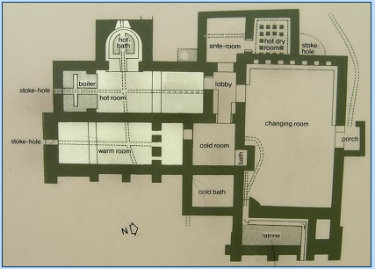
Choose to either: produce a labelled sketch of the plan (using a ruler) or make a model of a Bath House, using construction, card, paper and any other available materials you have. Perhaps you could also make figures to complete the look!
Again, make sure you photograph the evidence of your wonderful work and share it on Class Dojo. Happy making!

