TOPIC 27.4.20
Challenge 1 –
Create a fact-file on GLADIATORS, using the website: http://www.primaryhomeworkhelp.co.uk/romans/gladiators.html

Create a GLOSSARY of the new vocabulary you have now learned (what each word means). You should now know what a GLADIUS was and also a LUDI! Can you sketch a gladiator in action?

Challenge 2 – Using the same website… http://www.primaryhomeworkhelp.co.uk/romans/gladiators.html
…look at the images of the gladiator helmets.

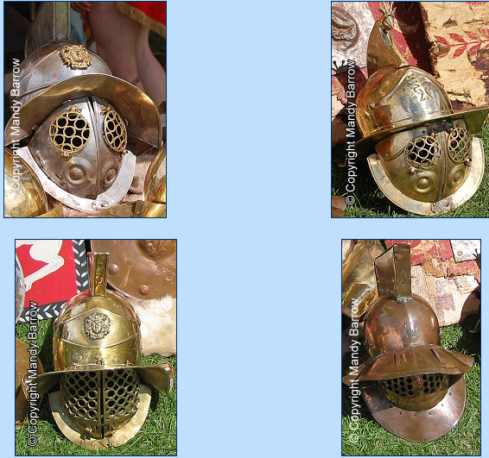
Choose to either: produce a sketch of a helmet or make a model of a helmet, using card, paper, foil and any other available materials you have. Perhaps you could also make a gladius and shield to complete the look!
Make sure you photograph the evidence of your wonderful work and share it on Class Dojo. Happy making!

