English 4.5.20
https://www.youtube.com/watch?v=5Ampy3IFt6k Watch this!
SPELLING
For each word you are given, answer the clues and practise the word. The chosen words are all from the National Curriculum Spelling Lists for Year 5 and 6. Write a definition of the word and include it in a sentence which contains a conjunction.
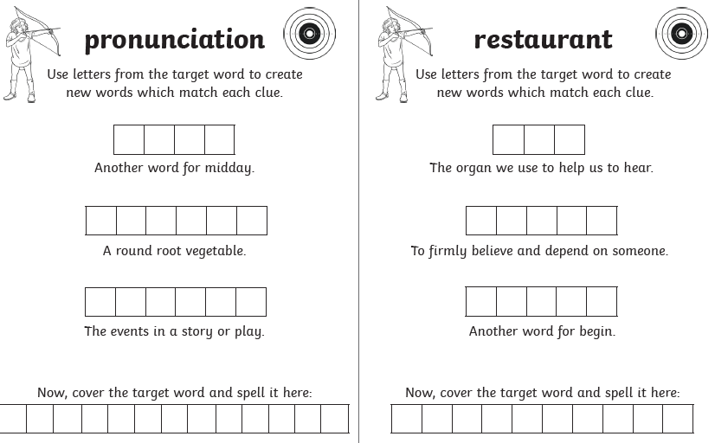
DAILY READING
Make sure you are reading something every day as you continue your journey towards becoming an ‘expert’. The better you become, the more enjoyment you will take from reading. FACT. Choose a title from the eBook library and enjoy! If you enter the library, you have the opportunity to create a login (as a parent) to access the free resources (email address required).
https://www.oxfordowl.co.uk/for-home/find-a-book/library-page/?view=image&query=&type=book&age_group=Age+9-11&level=&level_select=&book_type=&series=#

WRITING AND ACTIVITIES
Hamilton Trust Week 5 English planning. Follow the link and choose from the different activities on offer. There are plenty of concepts to revise and practise and it will provide you with a good idea about the expectations for Year 5 students.
https://www.hamilton-trust.org.uk/blog/learning-home-packs/

WEEK 5
Day 1- Using the poem, ‘What do you want to be?’ by Wilf Merttens.
Day 2- Using the poems, ‘Mother to Son’ by Langston Hughes, ‘Keep On Keeping On’ by Michael Sage and ‘Don’t Quit’ by Anon.
Day 3- Using the poem, ‘Hold Fast to Dreams’ by Langston Hughes.
Day 4- Using the poem, ‘What do you want to be?’ by Wilf Merttens.
Day 5- Innovating the poem, ‘What do you want to be?’ by Wilf Merttens.

ADDITIONAL ACTIVITIES
- Continue to watch ‘Newsround’ every day and write a summary of the main stories. https://www.bbc.co.uk/newsround/news/watch_newsround
It will act a little bit like a diary of your life at this time…something to look back at and remember!

Give each episode a title which gives the main idea of the broadcast and date it.
For every episode, write sub-headings for the individual features and a couple of sentences to describe the important details.

Remember to use accurate punctuation and vary your openers and conjunctions. Can you use fronted adverbials with a comma (,)?
Can you include a relative clause/ parenthesis (brackets)/-dashes-/,commas, using ‘who’, ‘which’, ‘that’ or ‘where’?

- Write a book review for a book you are currently reading, using the pro forma (template) I am providing. Follow the sub-headings and prompts to complete the activity. An alternative to reviewing a book might be to use the prompts to review a television programme or film you have watched. It should be an enjoyable way to reflect on what you have experienced.



