Challenge 1 –

Continue to watch ‘Newsround’ every day and write a summary of the main stories. https://www.bbc.co.uk/newsround/news/watch_newsround
It will act a little bit like a diary of your life at this time…something to look back at and remember!

Give each episode a title which gives the main idea of the broadcast and date it.
For every episode, write sub-headings for the individual features and a couple of sentences to describe the important details.

Remember to use accurate punctuation and vary your openers and conjunctions. Can you use fronted adverbials with a comma (,)?
Can you include a relative clause/ parenthesis (brackets)/-dashes-/,commas, using ‘who’, ‘which’, ‘that’ or ‘where’?

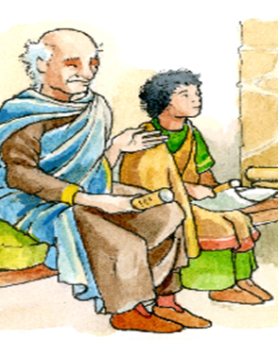
This is the start of a story set during the Roman occupation of Britain. Who are the main characters?
Why is Marcus in Britain?
What is different about Britain compared to Italy?
Describe Marcus. (character / appearance)

Challenge 3 – Aim for at least 15 words. Check the spellings.
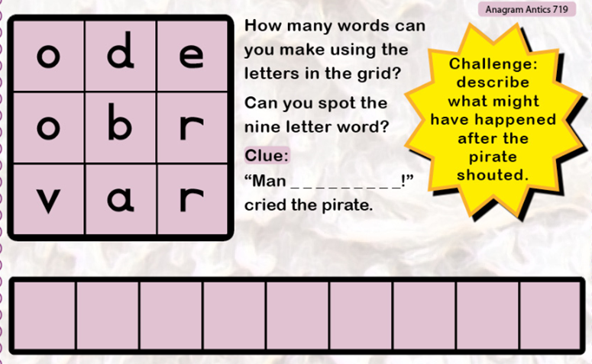
Challenge 2 –
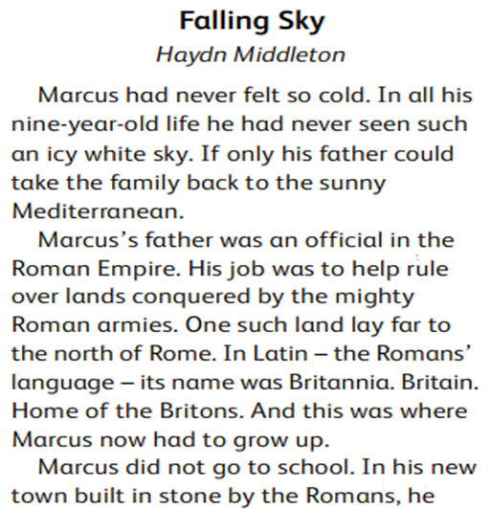
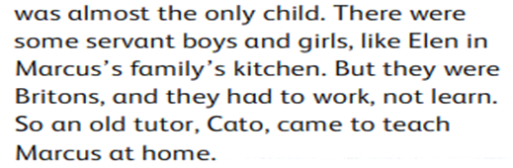
Challenge 5 –
Write a book review for a book you are currently reading, using the pro forma (template) I am providing. Follow the sub-headings and prompts to complete the activity. An alternative to reviewing a book might be to use the prompts to review a television programme or film you have watched. It should be an enjoyable way to reflect on what you have experienced.
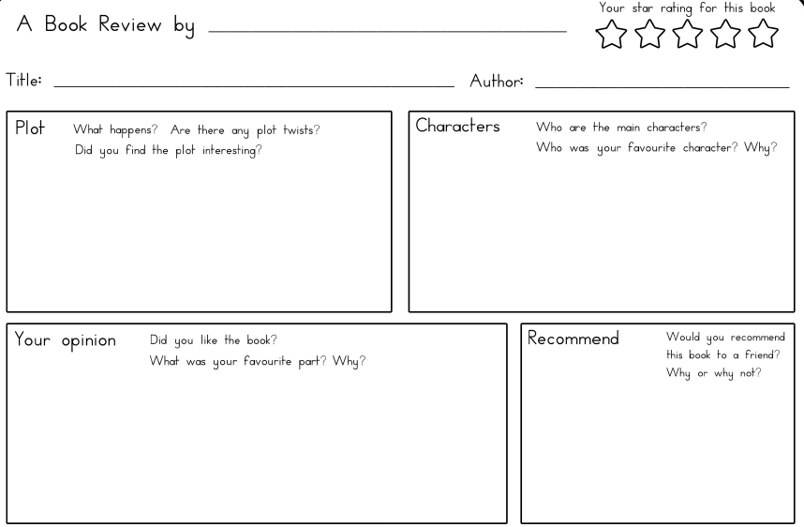

Use the following openers:
First of all,
It is clear to see that
Next,
As well as that,
Also,
Conjunctions (and as because so if when where)

Challenge 4 – Vocabulary (girl, boy, zip-line, seat, rope, pulley, platform, bark chippings)


