Challenge 1 –

Watch ‘Newsround’ every day and write a summary of the main stories. https://www.bbc.co.uk/newsround/news/watch_newsround

Give each episode a title which gives the main idea of the broadcast and date it.
For every episode, write sub-headings for the individual features and a couple of sentences to describe the important details.

Remember to use accurate punctuation and vary your openers and conjunctions. Can you use fronted adverbials with a comma (,)?
Can you include a relative clause/ parenthesis (brackets)/-dashes-/,commas, using ‘who’, ‘which’, ‘that’ or ‘where’?

This a WW2 propaganda poster which links very well to what is happening right now in 2020.
First of all, describe what is going on in the two pictures and what it was trying to encourage back in the 1940s.
Now, describe some of the difficulties your family might have experienced recently in trying to buy some of your essentials at home.
What should people do to try to be fair to everyone else?
Challenge 3 – Aim for at least 15 words. Check the spellings.
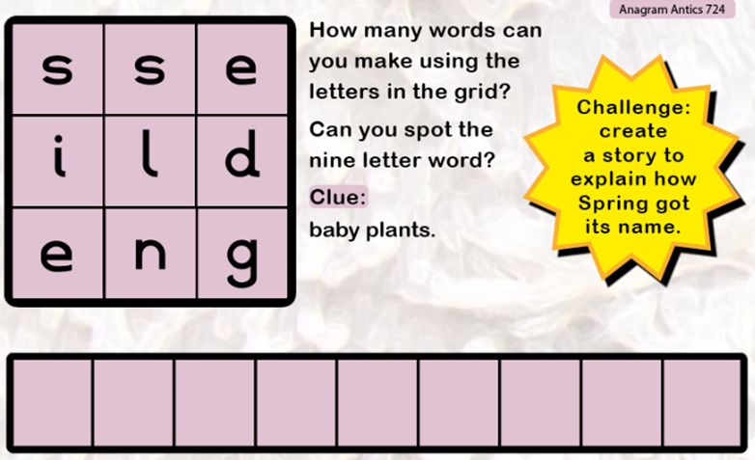
Challenge 2 –
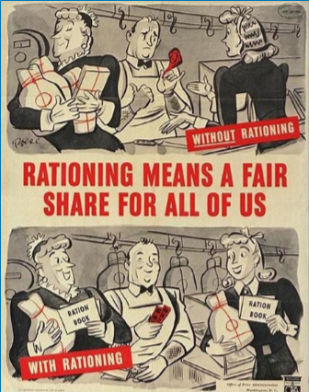
Challenge 5 –
Rewrite the sentences, remembering to punctuate the nouns accurately to show possession.
For example: Mr Hannams pencil should be written Mr Hannam’s pencil because the pencil belongs to him. As you know, apostrophes aren’t used to make plurals. Pens just means more than one pen and sweets means more than one sweet.
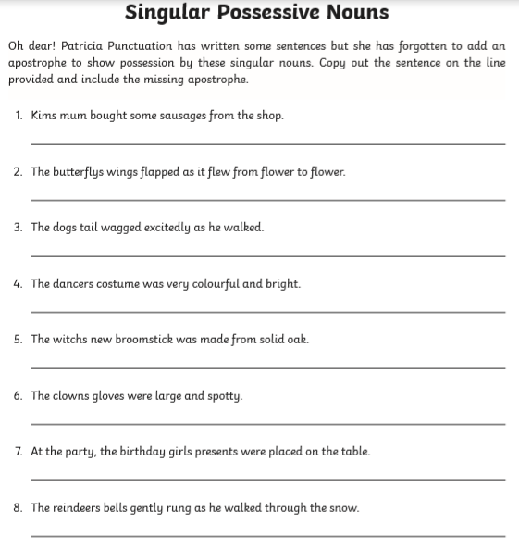

Challenge 4 –


