Human Digestive System
- Match the words provided to the letters in the diagram of the digestive system. Put your answer in the table:

Liver Stomach Salivary glands Pancreas Rectum Mouth

Oesophagus Gall Bladder Small intestines Large intestines

Letter | Part of Digestive System
A
B
C
D
E
F
G
H
I
J
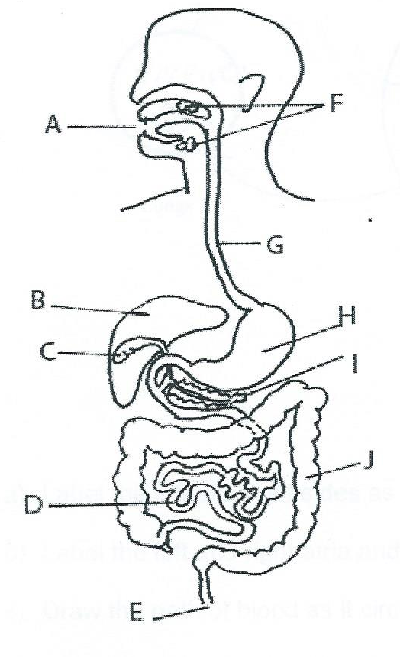

- Which of the following gives the correct order for food as it passes through the organs of the digestive system?
  - Mouth, oesophagus, stomach, gall bladder, pancreas, large intestines, small intestines
  - Oesophagus, epiglottis, stomach, liver, small intestines, large intestines, anus
  - Mouth oesophagus, stomach, small intestines, large intestines, anus
  - Mouth, liver, gall bladder, stomach, large intestines, small intestines, anus.

- Which part of the digestive system is responsible for absorbing water:
  - Small intestines
  - Large intestines
  - Kidneys
  - Stomach

- Which part of the digestive system contains Hydrochloric acid and is coated with mucus for its protection:
  - Rectum
  - Small intestines
  - Stomach
  - Oesophagus

- Which part of the following is the section of the digestive system where most enzymes are added?
  - Large intestines
  - Mouth
  - Stomach
  - Small intestines

- Bile is made in ________?
  - Liver
  - Stomach
  - Gall bladder
  - Small intestines

- Bile is made in the liver and released into the small intestine. Its job is to break down __________?
  - Nutrients
  - Fats
  - Proteins
  - Water

- The oesophagus connects the mouth to the _________?
  - Mouth
  - Small intestines
  - Liver
  - Stomach

- Which of the following are NOT a part of the digestive system?
  - Oesophagus
  - Kidneys
  - Anus
  - Liver
- Where is solid waste (poop) stored?
  - Anus
  - Rectum
  - Large intestines
  - Stomach

- Villi are found in what part of the digestive system?
  - Mouth
  - Stomach
  - Large intestines
  - Small intestines
- Diarrhoea is when the __________ do not absorb water?
  - Rectum
  - Anus
  - Stomach
  - Large intestines

- Which of the following best describes the role of the oesophagus in the digestive system:
  - Mucus is secreted to protect stomach
  - Sends food from mouth the stomach
  - Helps absorb nutrients
  - Breaks down food to be absorbed into bloodstream

- The main function of the stomach is to:
  - Store food
  - Produce hydrochloric acid
  - Break down food
  - All of the above

- Which of the following organs help break down food in the small intestines:
  - Liver, kidneys, stomach
  - Mouth, oesophagus, stomach
  - Liver, pancreas, gall bladder
  - Stomach, small intestines
- The “tentacle” like structure along the small intestines are called ____________:
  - Capillaries
  - Bile
  - Liver
  - Villi

