Science
For science this week you are required to look at flowers and dissect one. Watch the video below about the reproduction of plants.
https://www.bbc.co.uk/teach/class-clips-video/how-plants-and-animals-reproduce/zm8fbdm
After that, you will have to go on a hunt to find a flower, that you would be able to dissect (ideally with an adult from a place that is okay). Look at the flowers in the resources sheet that goes with this lesson to see what flowers you could use.

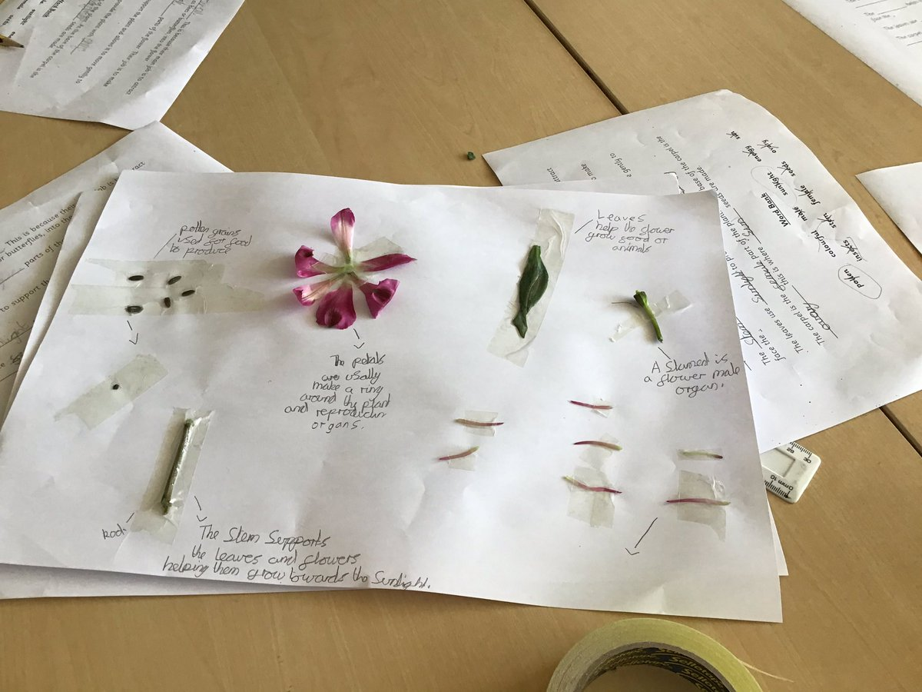
Follow the instructions in the resources and see if you can identify and possibly label the parts of a flower that you can see. An example is shown below (if you wish to make something like this).

