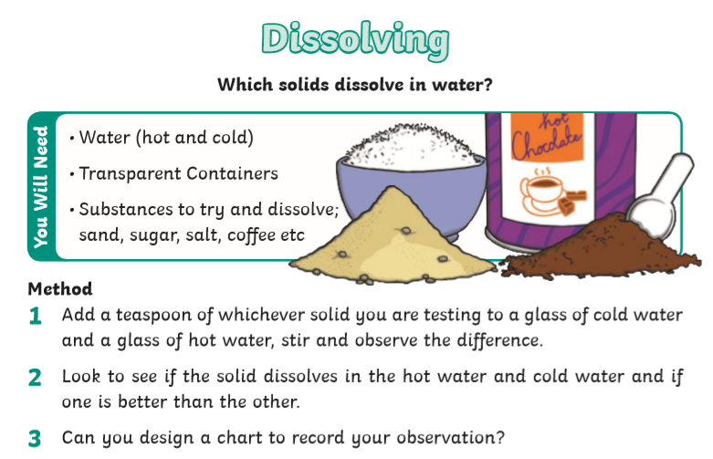
Conduct this experiment with your grown-ups permission and assistance (as it is using hot water).
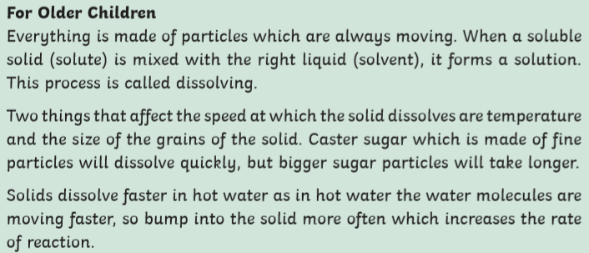
With permission, test to see if you can find any more solids that dissolve in either hot or cold water. Write them down with a prediction before you test them.

