SCIENCE 13.7.20
Challenge 1 – It’s recap time! This is a chance to reflect on how to behave like a scientist… follow the links and do the extra activity.
If you have any of the equipment at home, try using it…safely.
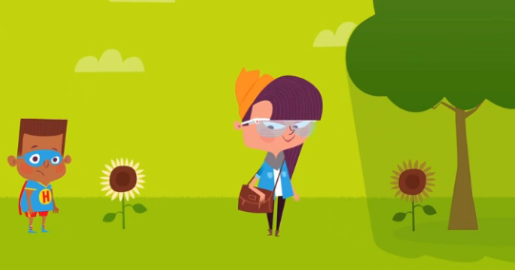https://www.bbc.co.uk/bitesize/topics/zxjj6sg/articles/z2qqj6f
Compare some similar living things by asking YES or NO questions to sort them, in a similar way to the frog and toad (animal or plant).
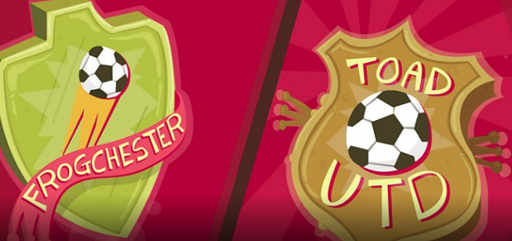https://www.bbc.co.uk/bitesize/topics/zxjj6sg/articles/z9cbcwx

252 ÷ 7 =
Challenge 2- Continue looking at scientific behaviour by watching these clips…then doing the extra activities… https://www.bbc.co.uk/bitesize/topics/zxjj6sg/articles/zg496yc
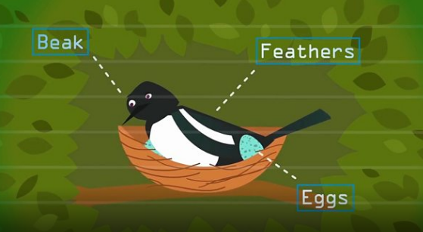
https://www.bbc.co.uk/bitesize/topics/zxjj6sg/articles/z98xb82
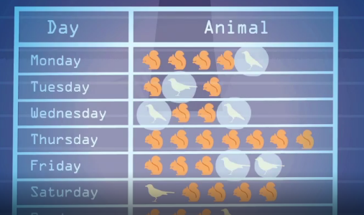
Try tallying the number of birds or creatures in your garden or in an alternative outdoor space.
There are also 8 ‘Skills’ class clips to watch! https://www.bbc.co.uk/bitesize/topics/zxjj6sg/resources/1 Enjoy them and make notes on what you discover.

