SCIENCE 6.7.20
Challenge 1 – Follow these instructions to try to grow your own plant by TAKING CUTTINGS…
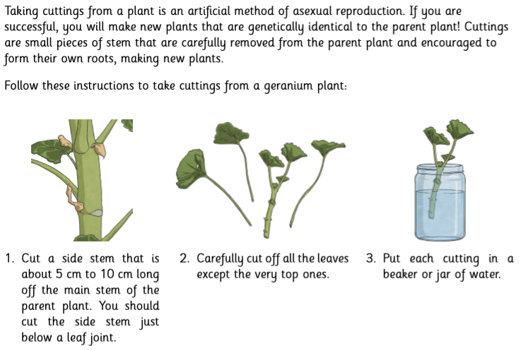
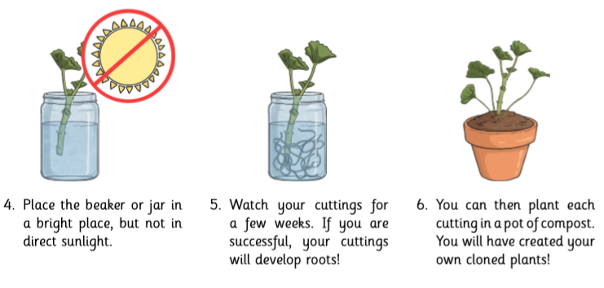

252 ÷ 7 =

Questions…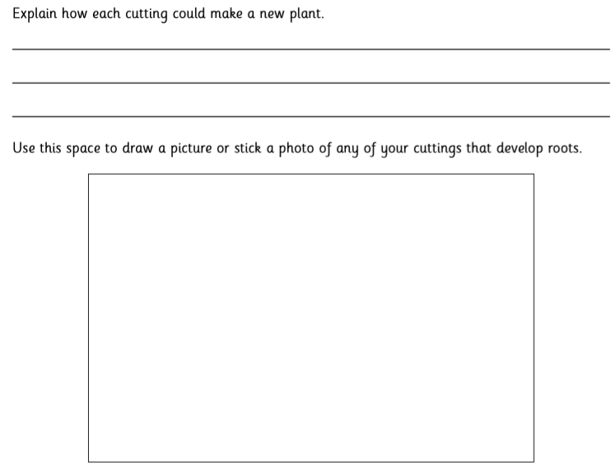
Challenge 2

Challenge 2- Follow the link…https://www.youtube.com/watch?v=aoXfocdh6L4 and try to press your own flowers. USE AN ADULT WHEN NECESSARY! Choose one of these pieces of work as inspiration and create your own version, using any of the techniques you watched in the clip. Share your marvellous work on Class Dojo and celebrate your artistic genius!


