SCIENCE 29.6.20
Challenge 1 – Follow this link…https://www.bbc.co.uk/bitesize/clips/zfx76sg Then, try the practical activity to collect these features.
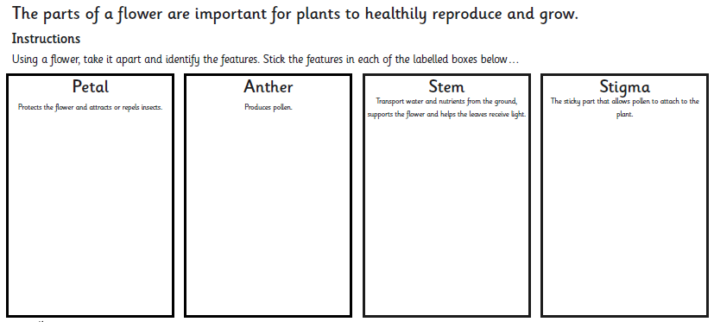

252 ÷ 7 =

Challenge 2

Challenge 2- Gustav Klimt (1862-1918) was an Austrian symbolist painter and is noted for his paintings, murals, sketches, and other objet d'art. Choose one of his pieces of work as inspiration and create your own version, using any techniques or media you choose. Share your marvellous work on Class Dojo and celebrate your artistic genius! Find out more about his life and work if you can.


