SCIENCE 8.6.20
Challenge 1 – Follow this link… https://web.extension.illinois.edu/gpe/case1/facts.html …draw and label sketches about ‘Plant Structure’ and ‘Life Cycle’. The hyperlinks take you to a Glossary. Create your own Glossary about this topic (In search of Green Life).
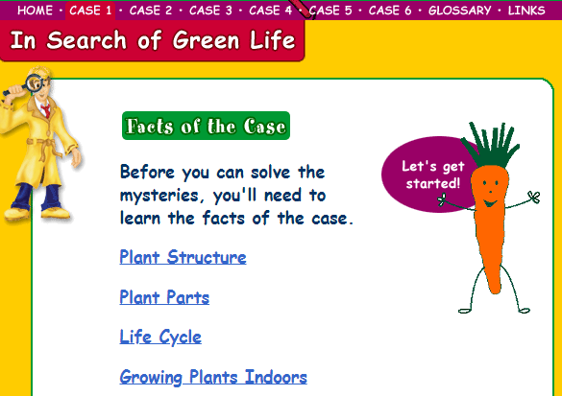 Just these two this week!

252 ÷ 7 =

Challenge 2

Challenge 2- Vincent Willem van Gogh (1853-1890) was a Dutch post-impressionist painter who is among the most famous and influential figures in the history of Western art. Choose one of his pieces of work as inspiration and create your own version, using any techniques or media you choose. Share your marvellous work on Class Dojo and celebrate your artistic genius! Find out more about his life and work if you can.


