SCIENCE 1.6.20
Challenge 1 – Sketch the plant and complete the sentences…
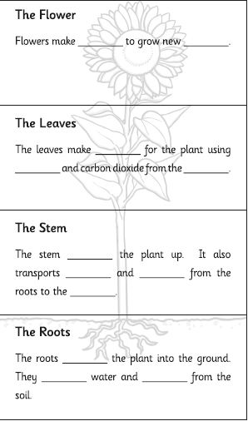

252 ÷ 7 =
Use the vocabulary provided to fill in the gaps…
anchor holds leaves water nutrients seeds food air nutrients plants absorb sunlight

Challenge 2

Challenge 2- Andy Goldsworthy OBE (born 26 July 1956) is a British sculptor, photographer and environmentalist who produces site-specific sculptures and land art situated in natural and urban settings. He lives and works in Scotland. Choose one of his pieces of work as inspiration and create your own version, using any techniques or media you choose. Share your marvellous work on Class Dojo and celebrate your artistic genius! Find out more about his life and work if you can.


