SCIENCE 25.5.20
Challenge 1 – Sort the statements about POLLINATION…
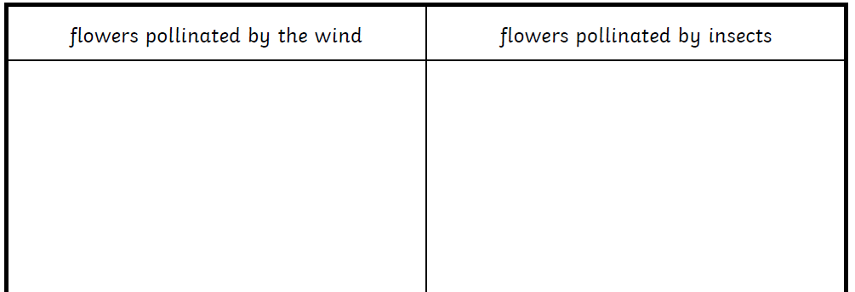
4 answers 5 answers
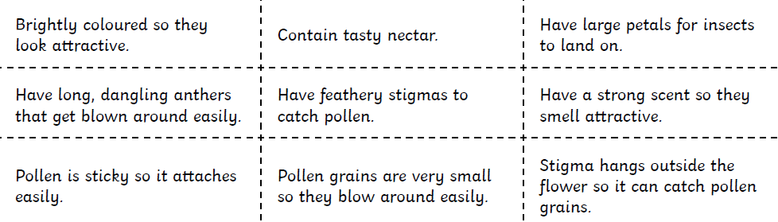

252 ÷ 7 =
Some plants are pollinated by the wind, and some plants are pollinated by insects.
Sort the statements and place them in the correct column according to whether they are about insect pollination or wind pollination.
Look back at the Bitesize clips you have watched.

Challenge 2

Challenge 2- Oscar-Claude Monet (14th November 1840–5th December 1926) was a French painter and founder of French Impressionism. Choose one of his pieces of work as inspiration and create your own version, using any techniques or media you choose. Share your marvellous work on Class Dojo and celebrate your artistic genius! Find out more about his life and work if you can.


