SCIENCE 18.5.20
Challenge 1 –Sketch and label the parts of a flowering plant…
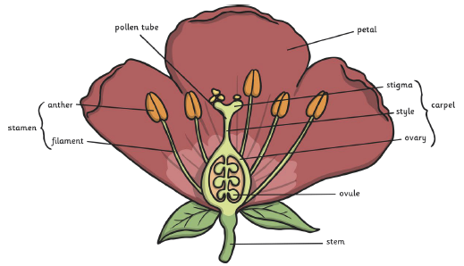

252 ÷ 7 =
REMEMBER…
Use colours to enhance your sketch.
EXTRA… Find out the meaning of the following; Anther Filament Style Stigma Ovary Petal.
What does each part do?
Challenge 2

Challenge 2-Follow this link to the Bitesize activity about how plants reproduce…
https://www.bbc.co.uk/bitesize/articles/znghnrd Watch the two videos…
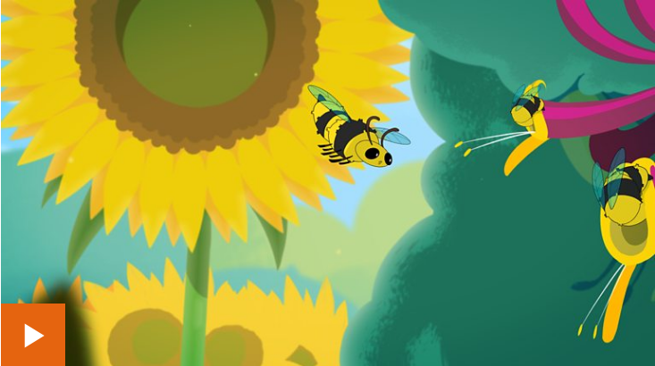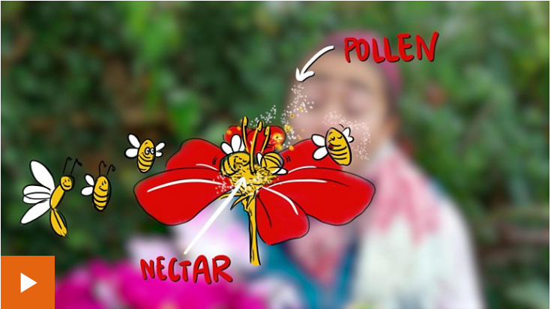
and do the two activities…


