SCIENCE 11.5.20
Challenge 1 –Sketch and label the life-cycle of a flowering plant…
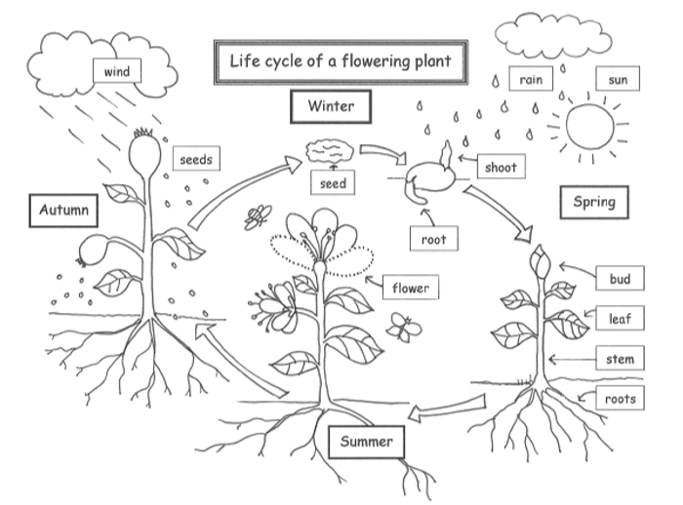
252 ÷ 7 =
REMEMBER…
Use colours to enhance your sketch.
EXTRA… Find out the meaning of the following;
Germination, Pollination, Fertilisation, Seed Dispersal.
Where would these labels fit on the Life cycle?
Challenge 2

Watch these 4 Learner Guides…https://www.bbc.co.uk/bitesize/topics/zy66fg8
What is a plant? What does a plant need to live? Why are bees attracted to flowers? What are the requirements for plant growth?
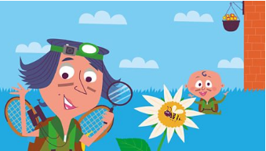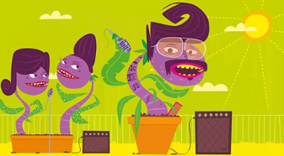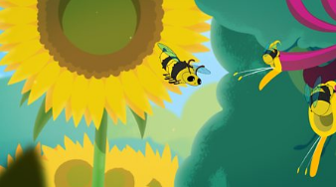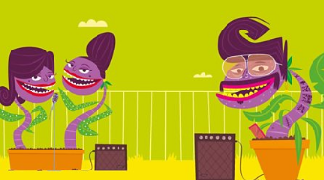
Summarise the content of each clip so you have a record of what you’ve learned (bullet points will do). Find out the meaning of any new vocabulary and be curious!

