SCIENCE 4.5.20
Challenge 1 – Research a new material invention, following the guidance on what to find out…
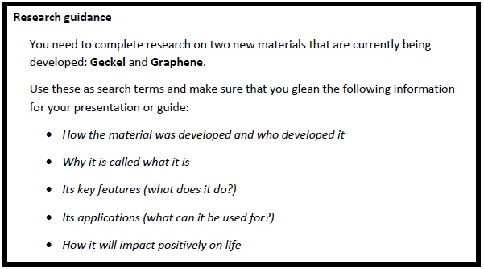
252 ÷ 7 =
Challenge 2 Have some interesting fun… but seek the permission of your grown-up first!
Make GOO!

REMEMBER…
Use sections (with sub-headings) to organise your research and label any sketches you do.


