SCIENCE 27.4.20
Challenge 1 –
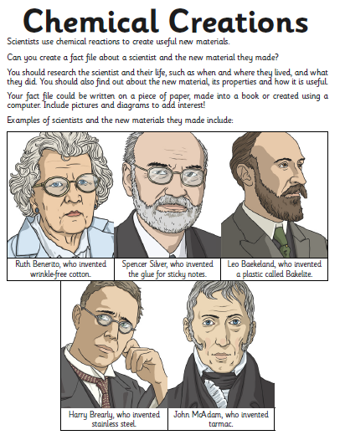
252 ÷ 7 =
Challenge 2 – Properties describe what a material is like. For instance, glass is a suitable material for windows because it is transparent, rigid and waterproof.
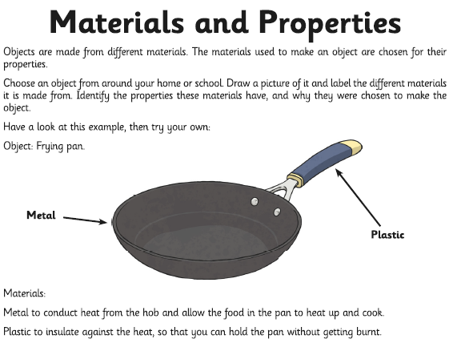

Or…you can think of your own invented material and focus on the scientist who created it.
Use sections (with sub-headings) to organise your research.

