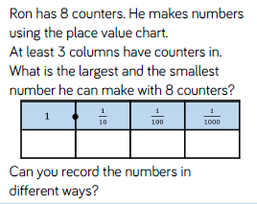
Challenge 1 –
Use place value (T 1s . t h) and the ‘Hi 5’ rule for rounding (<5 rounds down and > or =5 rounds up). Hint: Only think about the tenths (t).
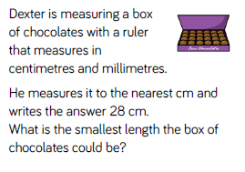
Write the largest length it could be as well.

Challenge 2 –

Take care with the tenths and the hundredths. Hint: The number will have to be less than 4. Use the ‘Hi 5’ rule for rounding.
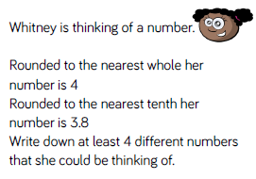
Challenge 3- Use place value (T 1s . t h) and the ‘Hi 5’ rule for rounding (<5 rounds down and > or =5 rounds up) Hint: Think about the hundredths. 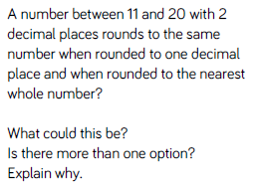

252 ÷ 7 =
Challenge 4 –
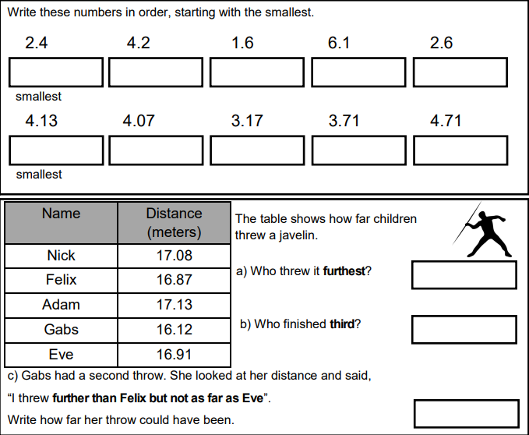

Challenge 5 –


