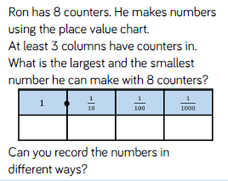
Challenge 1 –
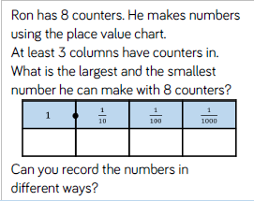 Use coins or counters to help you work this one out. Record all the possible numbers you can make first, then identify the largest and smallest.

Challenge 2 –
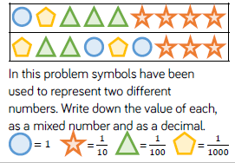
Take care with the order of the digits (they have been put down in the wrong order to fool you!) Which of the two numbers is the larger? How do you know?
Challenge 3- Use place value and check how each person is partitioning the same number.
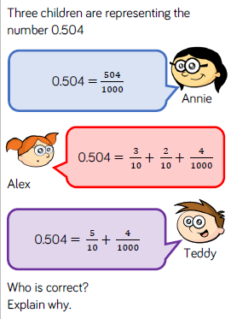
252 ÷ 7 =
Challenge 5 –
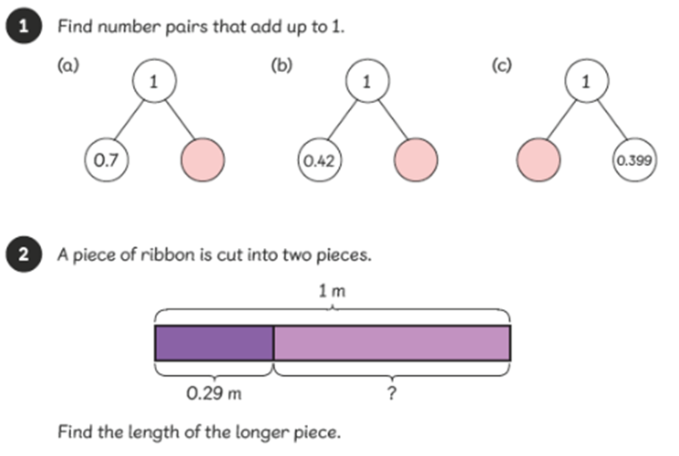 Can you write the length of this longer piece in m, cm and mm?

Challenge 4 – Choose 5 prime numbers (white) and 5 composite numbers (yellow). For each number you have chosen, write all the factor pairs. For example, 29= 1X29 (prime). 20=1X20, 2X10, 4X5 (composite).


